

**EPON OLT WEB**

**USER MANUAL**

**Version V2.0.2**

**Release Date 2017-06-02**

Contents

Chapter 1 System Description 6

1.1 Overview 6

1.1.1 OLT Introduction 6

1.1.2 PC System Requirement 6

1.2 Connection 7

Chapter 2 OLT Information 8

2.1 Login 8

2.2 Device Information 8

Chapter 3 OLT Configuration 10

3.1VLAN 10

3.1.1 New VLAN 10

3.1.2 VLAN Port 10

3.1.3 QinQ/Translation 11

3.2 Uplink Port 12

3.2.1 Information 12

3.2.2 Configuration 13

3.3 PON 14

3.3.1 Information 14

3.3.2 Configuration 15

3.4 MAC 15

3.4.1 MAC Table 15

3.4.2 Configuration 16

3.5 LACP 17

3.6 QOS 18

3.7 ACL 18

3.7.1 IP Filter 18

3.7.2 MAC Filter 19

3.7.3 IP/MAC Filter 20

3.7.4 Effect Filter 20

3.8 IGMP 21

3.8.1 Group Member 21

3.8.2 Global 21

3.8.3 Port 22

3.8.4 Port User VLAN 23

3.8.5 Port Mrouter 24

3.8.6 Static Group 24

3.9 RSTP 25

3.9.1 Information 25

3.9.2 Global 26

3.9.3 Port 27

3.10 DHCP 27

3.10.1 DHCP Server 27

3.10.2 DHCP Relay 29

3.10.3 DHCP Snooping 29

3.11 IP Route 32

3.11.1 VLAN IP 32

3.11.2 ARP Proxy 33

3.11.3 Static Route 34

Chapter 4 ONU Configuration 35

4.1 ONU List 35

4.1.1 Config 35

4.1.2 Profile 46

4.1.3 Deregister Reset Unauth 47

4.1.4 ONU Status 47

4.1.5 OPM Diag 48

4.2 Authentication 48

4.2.1 Authentication Mode 48

4.2.2 MAC list 49

4.2.3 LOID List 50

4.3 Upgrade 51

4.3.1 Upgrade Status 51

4.3.2 Manual Upgrade 51

4.3.3 Auto Upgrade 52

Chapter 5 Profile Configuration 53

5.1 DBA Profile 53

5.1.1 Add/Commit 53

5.1.2 Bandwidth 53

5.2 Service Profile 54

5.2.1 Add/Commit 54

5.2.2 Content 55

5.3 VoIP Profile 55

5.3.1 Add/Commit 55

5.3.2 Content 56

5.4 Alarm Profile 57

5.4.1 Add/Commit 57

5.4.2 Content 58

5.5 Bind Profile 59

5.5.1 Information 59

5.5.2 Configuration 60

Chapter 6 System Configuration 62

6.1 System Log 62

6.1.1 System Log 62

6.1.2 Alarm 63

6.1.3 Threshold Alarm 64

6.1.4 Syslog Server 65

6.2 Device Management 66

6.2.1 Firmware Upgrade 66

6.2.2 Device Reboot 66

6.2.3 Config File 67

6.3 User Management 67

6.4 SNMP 68

6.4.1 SNMP V1/V2 68

6.4.2 SNMP V3 69

6.4.3 SMNP V3 Trap 70

6.5 AUX IP 71

6.6 System Time 71

6.6.1 RTC 71

6.6.2 NTP 72

6.7 FAN 72

6.8 Mirror 73

Chapter 7 Configuration Examples 74

7.1 Internet With VLAN 100 74

7.2 IPTV With VLAN 200 76

7.3 VoIP With VLAN 300 79

# Chapter 1 System Description

## Overview

### 1.1.1 OLT Introduction

The WEB management user manual is for the OLTs listed in Table 1-1.

After you have completed installation, connection and commissioning of the equipment, you can start on configuring various services and functions for the equipment.

Table 1-1 OLT interfaces

|  |  |  |  |  |  |
| --- | --- | --- | --- | --- | --- |
| Products | | 2 ports EPON OLT(L) | 4 ports EPON OLT(L) | 8 ports EPON OLT | 16 ports EPON  OLT |
| Chassis | Rack | 1U 19 inch standard box | 1U 19 inch standard box | 1U 19 inch standard box | 1U 19 inch standard box |
| 1000M  Uplink Port | QTY | 4 | 8 | 16 | 12 |
| Copper | 2*10/100/1000M auto-negotiation | 4*10/100/1000M auto-negotiation | 8*10/100/1000M auto-negotiation | 4*10/100/1000M |
| SFP  (Independent) | 2*SFP | 4*SFP | 4*SFP and 4*SFP+ (SFP+ is compatible with 10GE) | 4*SFP and 4*SFP+ (SFP+ is compatible with 10GE) |
| EPON Port | QTY | 2 | 4 | 8 | 16 |
| Physical Interface | SFP Slots | SFP Slots | SFP Slots | SFP Slots |
| Management Ports | | 1*10/100BASE-T out-band port(AUX), 1*CONSOLE port | | | |
| Management Mode | | SNMP, WEB, Telnet and CLI | | | |

### 1.1.2 PC System Requirement

Table 1-2 PC System requirement

|  |  |  |  |  |
| --- | --- | --- | --- | --- |
| CPU | Memory | DISK | Video Card | Operating System |
| Frequency above 2GHz | 2GB  Or above | 10GB  disk space | 65000 color  resolving  capability  1024*768  and above | Windows2008  Windows XP  Windows 7  Windows 8  Windows 10 |

## 1.2 Connection

Connect the OLT AUX port to IP network. The OLT default management IP is 192.168.8.100.

Please set your PC IP to192.168.8.XXX (e.g.192.168.8.123).

AUX

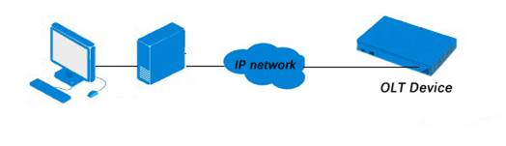

# Chapter 2 OLT Information

## 2.1 Login

Follow the steps to login:

1. Conform “1.2 Connection” to connect;

2. The device default IP address is 192.168.8.100;

3. Open your web browser, type the device IP in address bar;

4. Entry of the username and password will be prompted. Enter the default login User Name and Password. Both the username and password are "**admin**" by default.

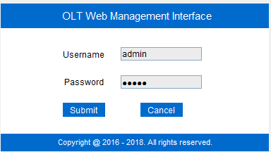

Figure 2-1: Login

## 2.2 Device Information

The OLT ports connection status are shown in the top of the interface, and about the OLT basic information.

Click **OLT Information**🡪**Device Information** to get the information.

This part shows the OLT information such as system name, serial number, hardware version, firmware version, MAC address and system time. The system name can be modified if need.

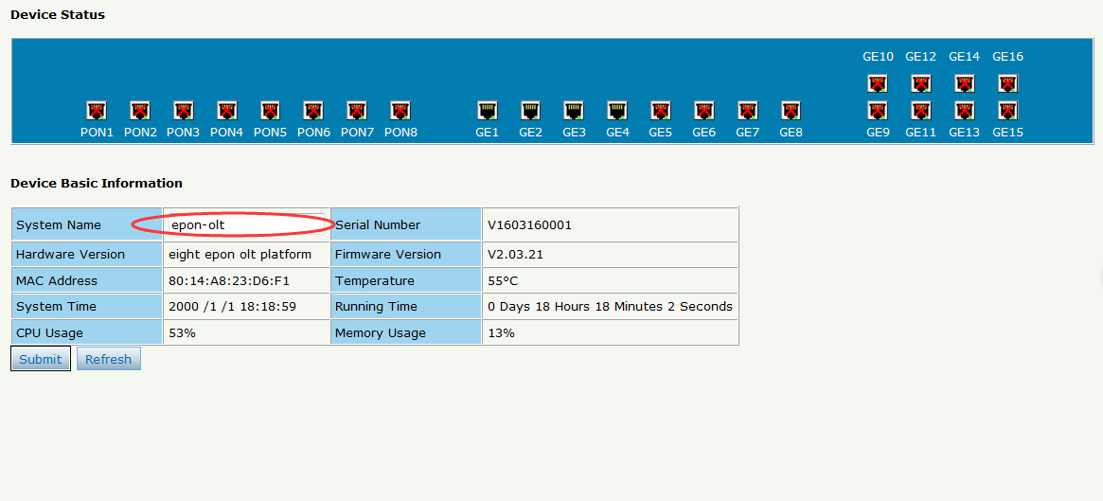

Figure 2-2: Device Information

# Chapter 3 OLT Configuration

This section is about the basic service of OLT configuration.

## 3.1VLAN

### 3.1.1 New VLAN

Click **OLT Configuration**🡪**VLAN** to create new VLAN.

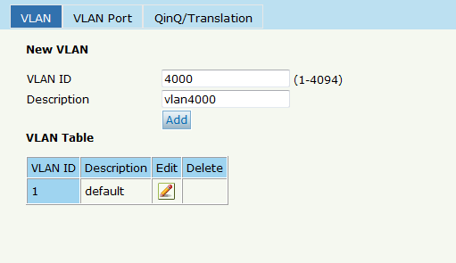

Figure 3-1: Create New VLAN

### 3.1.2 VLAN Port

Assign the ports to the VLANs you created. Here, you can choose the tag or untag VLAN mode. Click **OLT Configuration**🡪**VLAN**🡪**VALN Port** as shown in Figure 3-2.

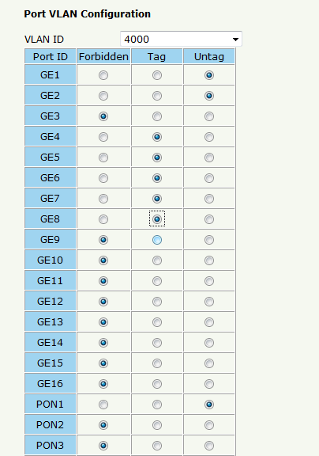

Figure 3-2: Add VLAN Port

### 3.1.3 QinQ/Translation

To configure the port mode VLAN translation or double VLAN tag, click **OLT Configuration**🡪**VLAN**🡪**QinQ/Translation**, as shown in Figure 3-3.

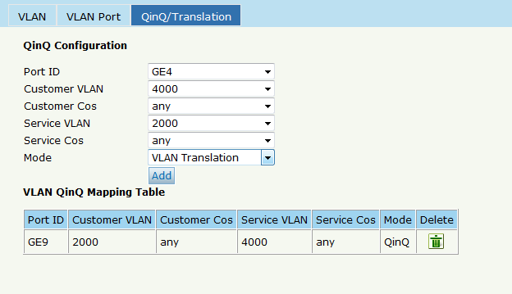

Figure 3-3: QinQ/Translation Configuration

## 3.2 Uplink Port

GE ports traffic statistics and basic configuration setting.

### 3.2.1 Information

Select **OLT Configuration**🡪**Uplink Port**🡪**Information**, as shown in Figure 3-5.

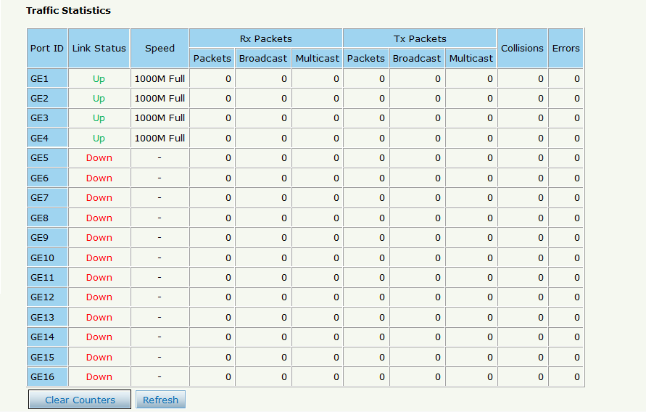

Figure3-4 : GE Traffic Statistcs

### 3.2.2 Configuration

The GE ports basic configuration can be set. Select **OLT Configuration** 🡪**Uplink Port**🡪**Information**, as shown in Figure 3-6.

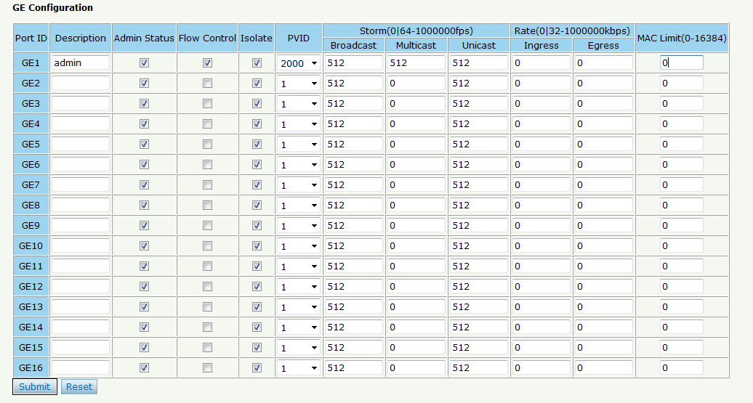

Figure3-5: Uplink Ports Configuration

## 3.3 PON

### 3.3.1 Information

The OLT PON ports information can be shown here, about the PON ports current temperature, Voltage, current, transmit power and the traffic statistics.

Select **OLT Configuration**🡪**PON**🡪**Information**, you can show the PON port parameters, as shown in Figure 3-6.

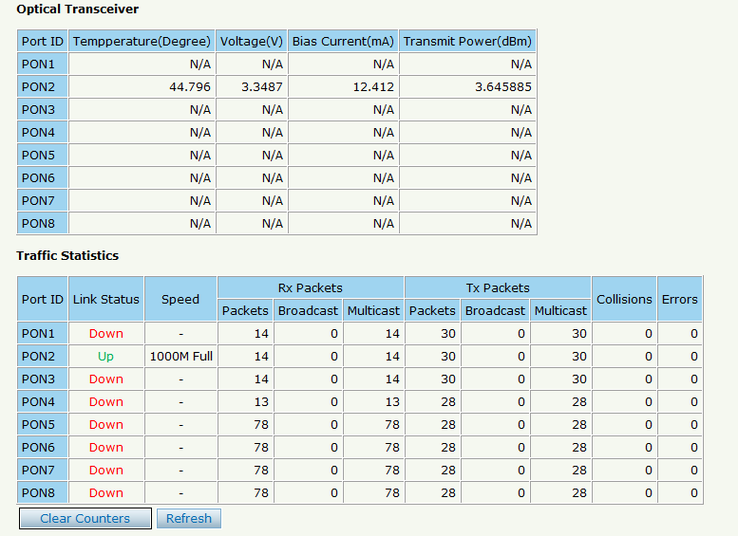

Figure3-6: PON Information

### 3.3.2 Configuration

The PON ports basic configuration can be set.

Select **OLT Configuration**🡪**PON**🡪**Configuration,** as shown in Figure 3-7.

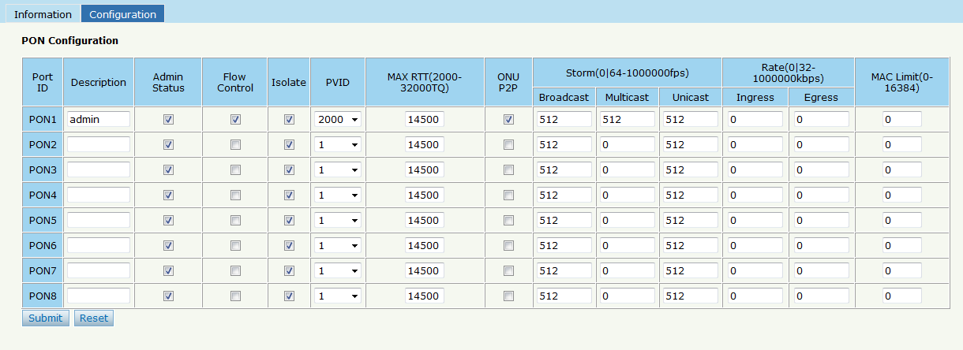

Figure3-7: PON configuration

## 3.4 MAC

### 3.4.1 MAC Table

All the OLT learning MAC can be shown.

Select **OLT Configuration**🡪**MAC**🡪**MAC Table,** as shown in Figure 3-8.

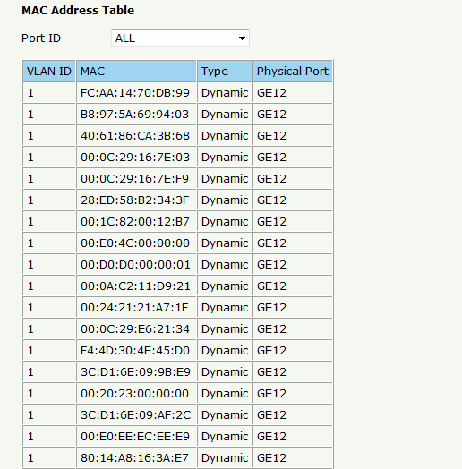

Figure3-8: MAC Address Table

### 3.4.2 Configuration

The default MAC aging time of OLT is 300s, user can change the value between 10~1000000s. Also, user can add the MAC to the OLT manually.

Select **OLT Configuration**🡪**MAC**🡪**Configuration,** as shown in Figure 3-9.

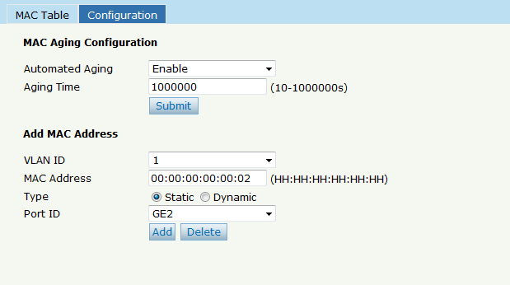

Figure 3-9:MAC Configuration

## 3.5 LACP

Select **OLT Configuration**🡪**LACP**🡪**Static LACP** to assign and configure a uplink physical interface to an Ether Channel. When a traffic link can't be used suddenly, this traffic link will switch to another link automatically. The group range is from 1 to 4.Each group can add 4 ports maximally. Only GE ports can be added in the channel groups.

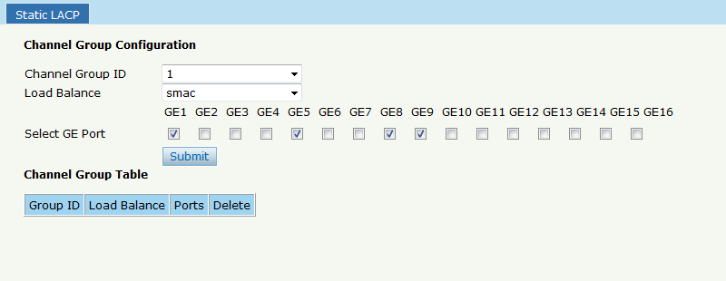

Figure 3-10: Create Static LACP

## 3.6 QOS

The EPON OLT supports layer 2 802.1p and layer 3 DSCP QOS. Frames can be placed in different queues and serviced via Strict Priority(SP),Weighted Round Robin (WRR) and SP+WRR. Select **OLT Configuration**🡪**QOS** to set QOS configuration, as shown in Figure 3-11.

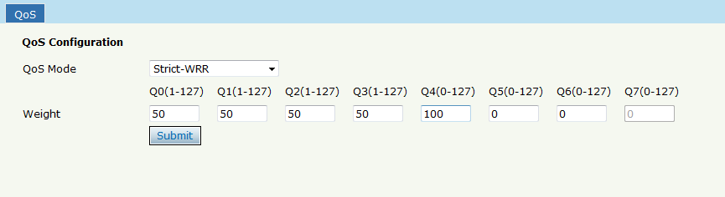

Figure 3-11: QOS Configuration

## 3.7 ACL

This part is about the security of OLT. It can permit or deny the clients access. Each access list can support 3 rules.

### 3.7.1 IP Filter

The filter is basic on the IP address, include source IP address and destination IP address.

Select **OLT Configuration**🡪**ACL** 🡪**IP Filter** to set the configuration, as shown in Figure 3-12.

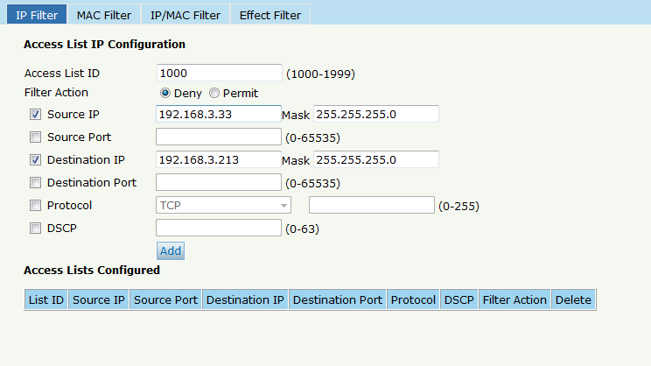

Figure 3-12: IP Filter

### 3.7.2 MAC Filter

The filter is basic on the MAC address, include source MAC address and destination MAC address.

Select **OLT Configuration**🡪**ACL** 🡪**MAC Filter** to set the configuration, as shown in Figure 3-13.

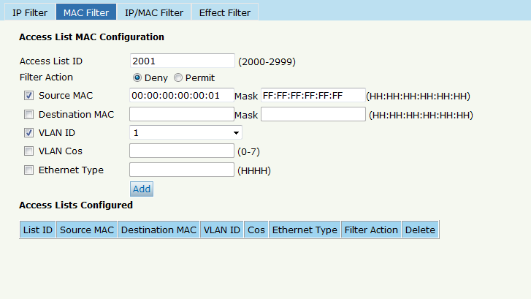

Figure 3-13: MAC Filter

### 3.7.3 IP/MAC Filter

This filter mix the IP address and MAC address, include source MAC address and destination MAC address, source IP address and destination IP address.

Select **OLT Configuration**🡪**ACL** 🡪**IP/MAC Filter** to set the configuration, as shown in Figure 3-14.

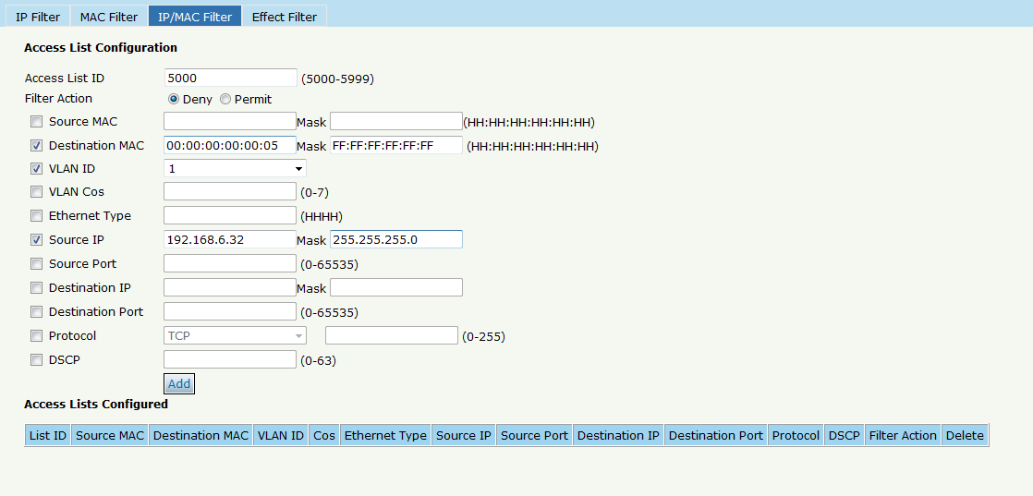

Figure 3-14 IP/MAC Filter

### 3.7.4 Effect Filter

Bind the access list to the ports then it can take effect. Each access list can be bound several ports.

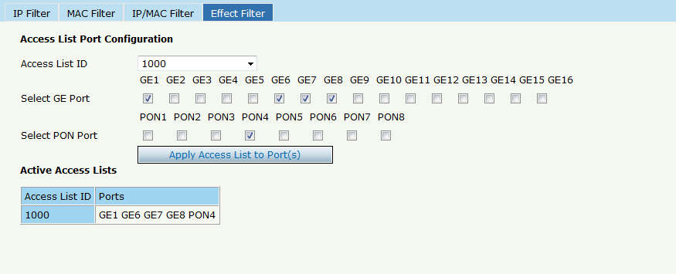

Figure 3-15: Bind Security Filter

## 3.8 IGMP

### 3.8.1 Group Member

Show about the group member in the list.

Select **OLT Configuration**🡪**IGMP** 🡪**Group Member** to set the configuration, as shown in Figure 3-16.

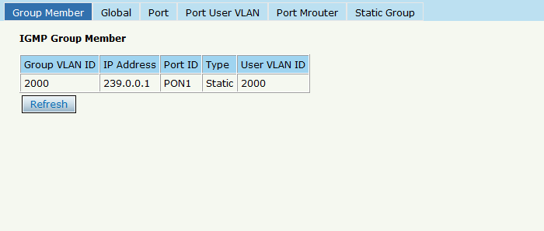

Figure 3-16: Group Member

### 3.8.2 Global

To enable the IGMP snooping mode, click **OLT Configuration** 🡪**IGMP**🡪**Global**.

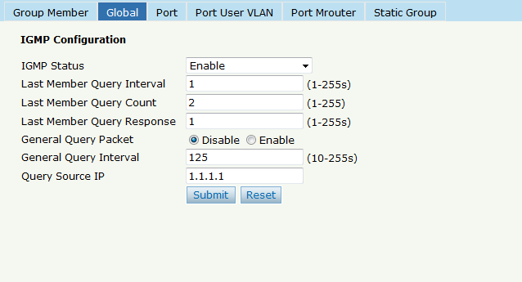

Figure 3-17: IGMP Global

### 3.8.3 Port

Click **OLT Configuration** 🡪**IGMP**🡪**Port**. to set group limit value, enable/disable fast leave and filter.

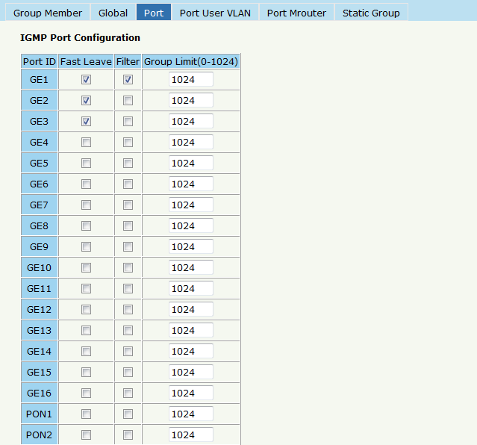

Figure 3-18: IGMP Port

### 3.8.4 Port User VLAN

Click **OLT Configuration** 🡪**IGMP**🡪**Port User VLAN** to configure the user VLAN and group VLAN.

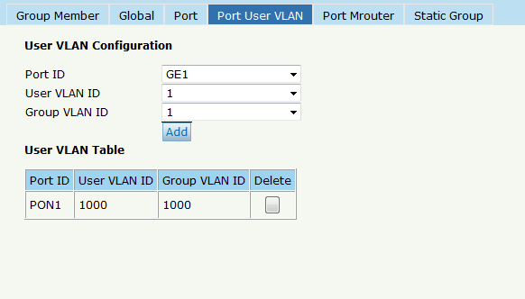

Figure 3-19: IGMP Port User VLAN

### 3.8.5 Port Mrouter

To add a port to the IGMP multicast routing group, click **OLT Configuration** 🡪**IGMP**🡪**Port Mrouter,** as shown in Figure 3-20.

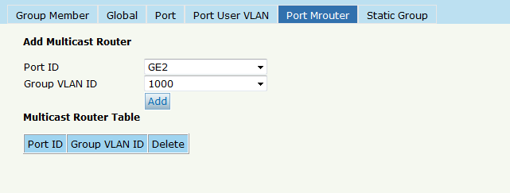

Figure 3-20: IGMP Port Mroute

### 3.8.6 Static Group

Add an IGMP group manually. Always choose the PON port as the group port. Click **OLT Configuration** 🡪**IGMP**🡪**Static Group,** as shown in Figure 3-21.

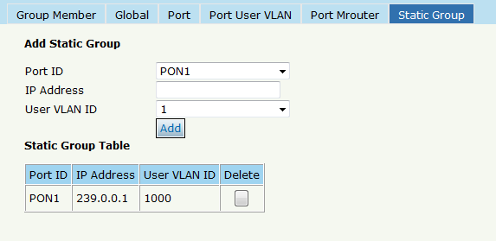

Figure 3-21: IGMP Static Group

## 3.9 RSTP

### 3.9.1 Information

The OLT is disabling RSTP by default. When enable the RSTP, the RSTP global information and port information can be shown by click **OLT Configuration**🡪**RSTP**🡪**Information**. See Figure 3-22.

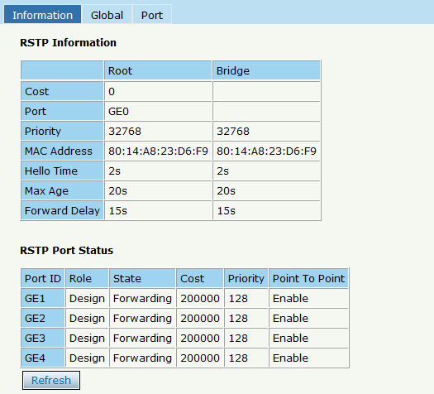

Figure 3-22:RSTP Information

### 3.9.2 Global

Enable the RSTP, click **OLT Configuration**🡪**RSTP**🡪**Global** to enable.

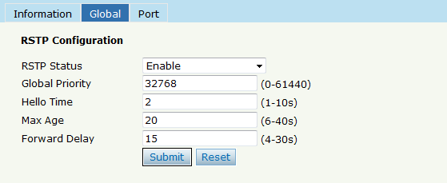

Figure 3-23: RSTP Global Setup

### 3.9.3 Port

The RSTP ports parameter can be set by selecting click **OLT Configuration**🡪**RSTP**🡪**Port** .

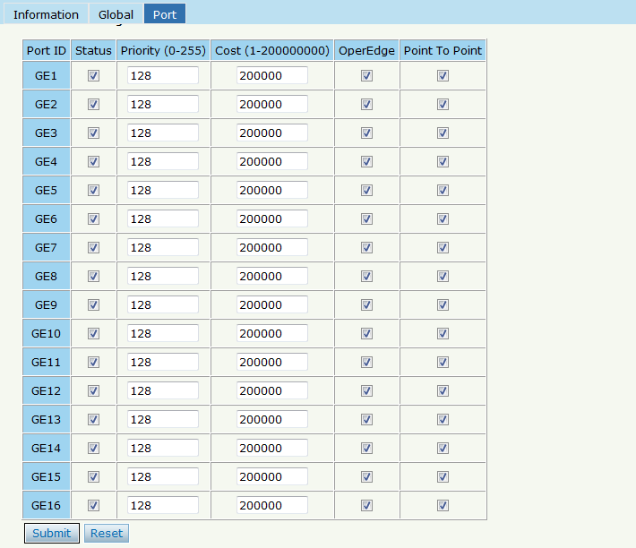

Figure 3-24: RSTP Port Setting

## 3.10 DHCP

### 3.10.1 DHCP Server

#### 3.10.1.1 DHCP Lease

Click **OLT Configuration🡪DHCP🡪DHCP Server🡪Lease**, the DHCP Server Lease will be shown as Figure3-25.

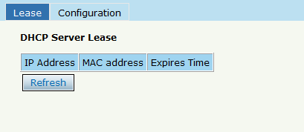

Figure 3-25: DHCP Lease

#### 3.10.1.2 DHCP Configuration

When enable OLT DHCP server, the connecting devices will obtain an IP address. Click **OLT Configuration🡪DHCP🡪DHCP Server🡪Configuration** to configure the DHCP Server, shown as Figure 3-26.

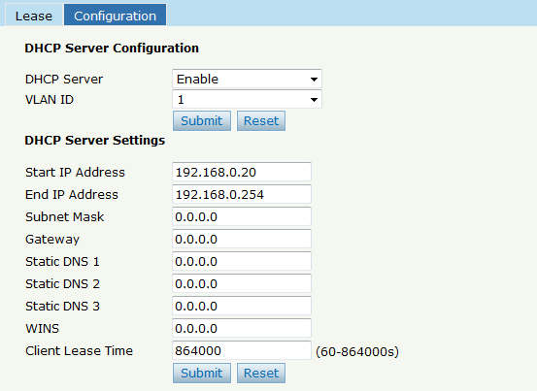

Figure 3-26:DHCP Configuration

### 3.10.2 DHCP Relay

#### 3.10.2.1 DHCP Relay Configuration

When the DHCP server and the clients are not in the same subnet, DHCP relay can help the clients get the IP address from the server. The relay server IP address network segment should be the same as the DHCP server.

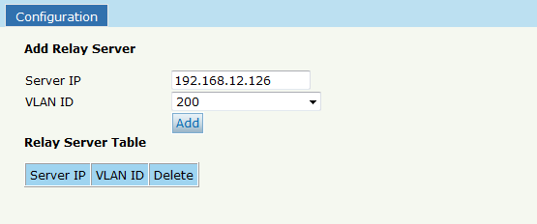

Figure 3-27:DHCP Relay Configuration

### 3.10.3 DHCP Snooping

#### 3.10.3.1 DHCP Snooping Bind List

The static bind of the DHCP Snooping will be shown , Click **OLT Configuration🡪DHCP🡪DHCP Snooping🡪Bind List**

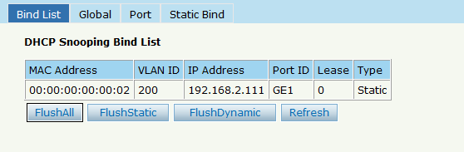

Figure 3-28:DHCP Snooping Bind List

#### 3.10.3.2 Global

To prevent the DHCP message attacking and protect your network to get a useful IP address, it can deny the DHCP offers packets. DHCP Snooping is used for denying the DHCP offers packets. The DHCP server is forbidden, which cannot allocate the IP address successfully. Click **OLT Configuration🡪DHCP🡪DHCP Snooping🡪Global** to enable DHCP Snooping.

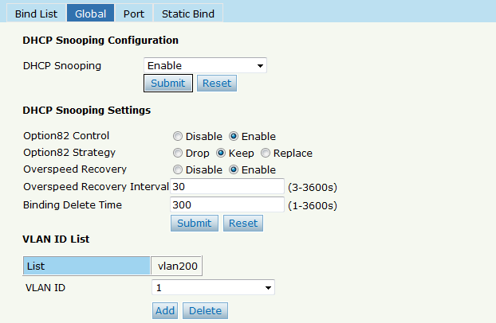

Figure 3-29:DHCP Snooping Global

#### 3.10.3.3 Port

The DHCP snooping ports are untrust by default. Click **OLT Configuration🡪DHCP🡪DHCP Snooping🡪Port** to configure

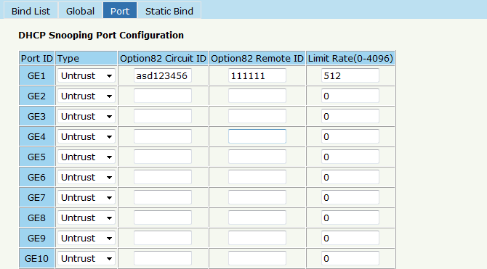

Figure 3-30:DHCP Snooping Port Setup

#### 3.10.3.4 Static Bind

Fill in the MAC address, choose the VLAN ID, port ID and the lease time. Click **OLT Configuration🡪DHCP🡪DHCP Snooping🡪Static Bind** to configure, as shown in Figure 3-31.

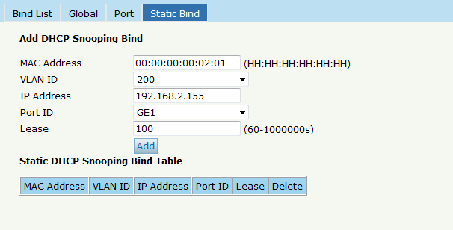

Figure 3-31 DHCP Snooping Static Bind

## 3.11 IP Route

### 3.11.1 VLAN IP

Select the existing VLAN and set an IP address for this VLAN, as shown in Figure 3-32.

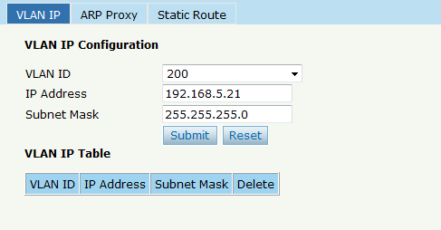

Figure 3-32:VLAN IP

### 3.11.2 ARP Proxy

When serves as a ARP proxy, the OLT processes the ARP request message via configuring the VLAN as the layer 3 interface. The VLAN ID configuration value ranges is from 1 to 4085.

First, configure the VLAN IP.

Then enable the ARP proxy.

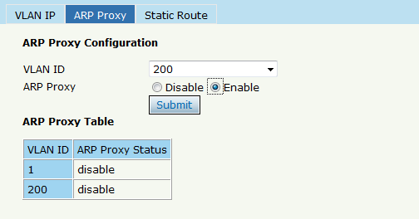

Figure 3-33: ARP proxy configuration

### 3.11.3 Static Route

OLT supports static route L3 function. Click **Static Route** to configure, as shown in Figure 3-34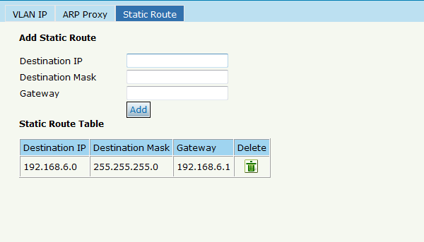

Figure 3-34: Static Route

# Chapter 4 ONU Configuration

This chapter is about the ONU management by OLT.

## 4.1 ONU List

This page shows about the ONU authentication list, search the ONU by MAC.

Click **ONU Configuration🡪ONU List,** shown as Figure 4-1.

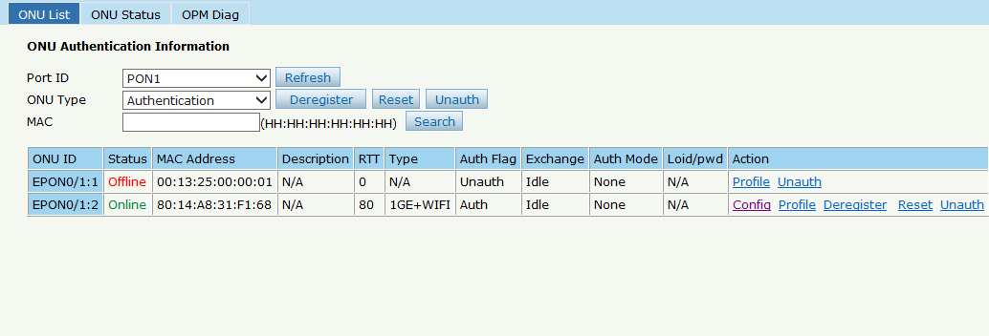

Figure 4-1 ONU List

### 4.1.1 Config

Click **ONU List🡪Config,** shown as Figure 4-2.

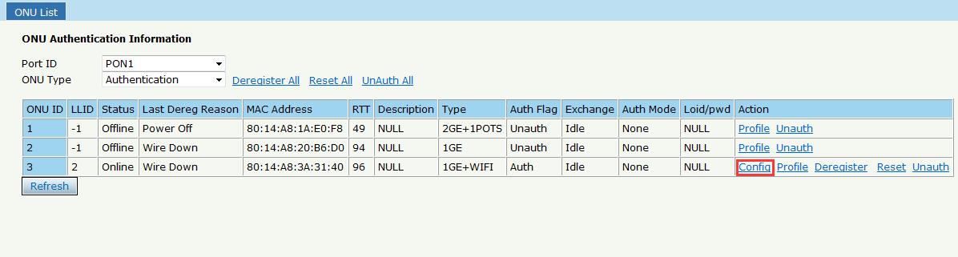

Figure 4-2 Configure ONU

#### 4.1.1.1 Information

Click **ONU List🡪Config🡪Information,** show the ONU information.

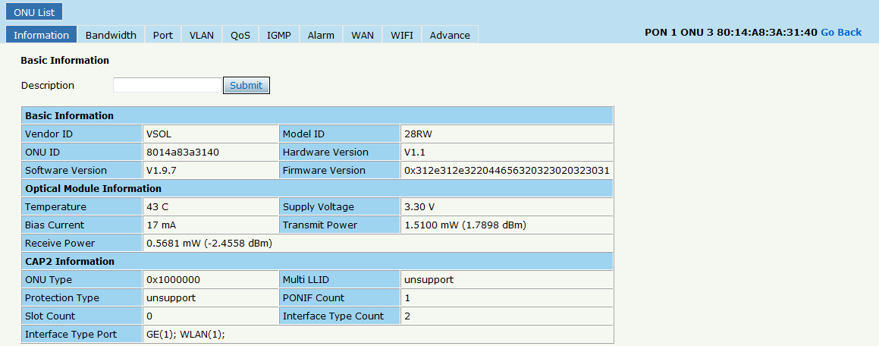

Figure 4-3 ONU Information

#### 4.1.1.2 Bandwidth

Limited the ONU upstream and downstream.

Click **ONU List🡪Config🡪Bandwidth**

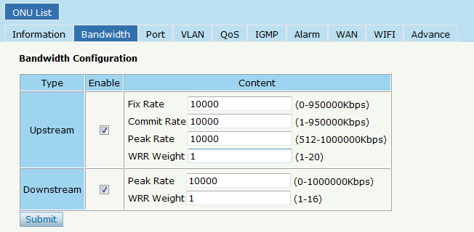

Figure 4-4 ONU Bandwidth

#### 4.1.1.3 Port

The ONU port basic configure switch can be operated. And this page can configure the ONU port bandwidth.

Click **ONU List🡪Config🡪Port,** shown as Figure 4-5

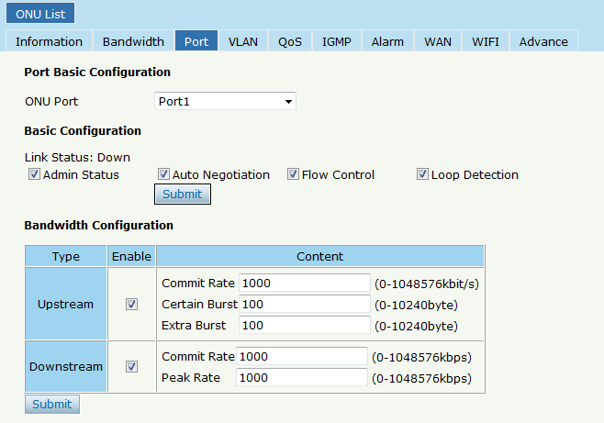

Figure 4-5 ONU Port Configuration

#### 4.1.1.4 VLAN

ONU port default VLAN mode is transparent, the VLAN mode can be changed to tag mode, translation mode, aggregation mode, trunk mode.

Click **ONU List🡪Config🡪VLAN,** shown as Figure 4-6.

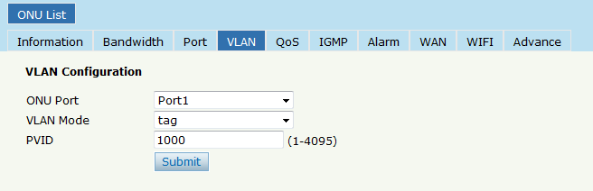

Figure 4-6 ONU Port VLAN

#### 4.1.1.5 QoS

The QoS take effect with ONU port. Click **ONU List🡪Config🡪QoS,** shown as Figure 4-7.

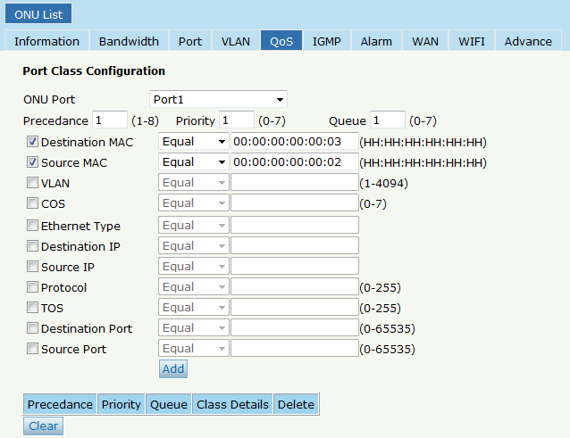

Figure 4-7 QoS Configuration

#### 4.1.1.6 IGMP

Configure the ONU IGMP mode(Snooping or CTC Control),and the IGMP VLAN mode.

Click **ONU List🡪Config🡪IGMP,** shown as Figure 4-8.

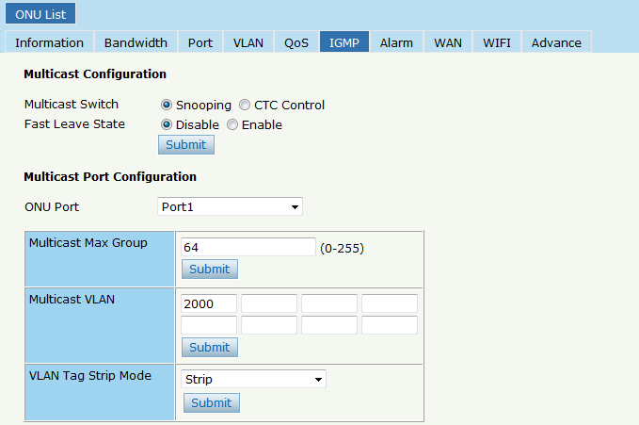

Figure 4-8 IGMP Configuration

#### 4.1.1.7 Alarm

Show the ONU alarm status and threshold. Click **ONU List 🡪 Config 🡪 IGMP ,** shown as Figure 4-9.

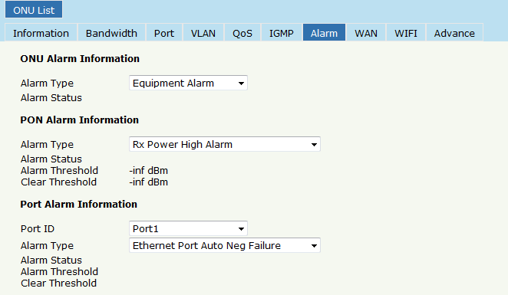

Figure 4-9 ONU Alarm

#### 4.1.1.8 WAN

This is the private OAM between OLT and ONU. When the connected ONU support this function, the option "WAN" can be show in this page.

Click **ONU List 🡪 Config 🡪WAN ,** fill in the parameter, click "**Add**" then click "Submit" it will take effect, shown as Figure 4-10.

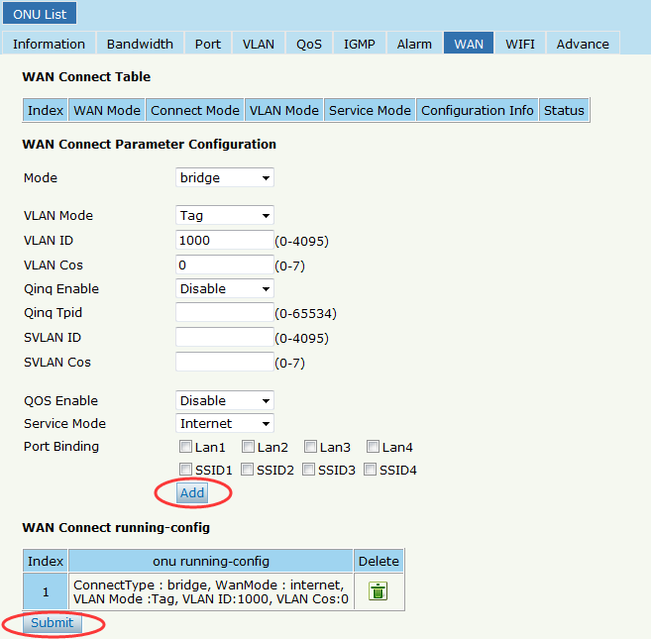

Figure 4-10 WAN Connection

#### 4.1.1.9 WIFI

This is the private OAM between OLT and ONU. When the connected ONU support this function, the option "WIFI" can be show in this page.

Click **ONU List 🡪 Config 🡪WIFI,** the SSID and the password can be set, shown as Figure 4-11.

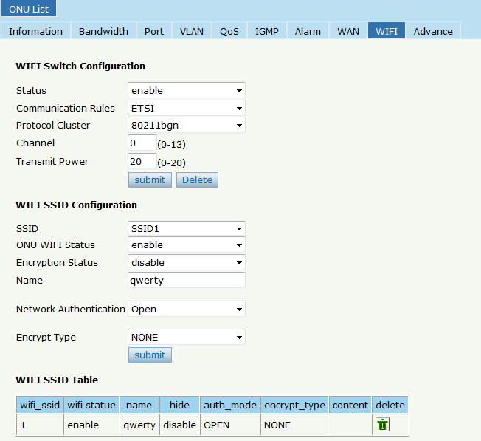

Figure 4-11 WIFI Setting

#### 4.1.1.10 DHCP Server

This is the private OAM between OLT and ONU. When the connected ONU support this function, the option "DHCP Server" can be show in this page.

Click **ONU List 🡪 Config 🡪DHCP Server,** the ONU Lan port DHCP server can be changed, shown as Figure 4-12.

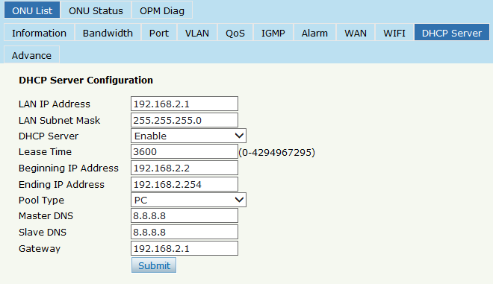

Figure 4-12 DHCP Server Setting

#### 4.1.1.11 Advance

ONU management IP and ONU MAC aging time can be set. The ONU which support management IP and MAC aging time can take effect. Click **ONU List 🡪 Config 🡪Advance,** shown as Figure 4-13.

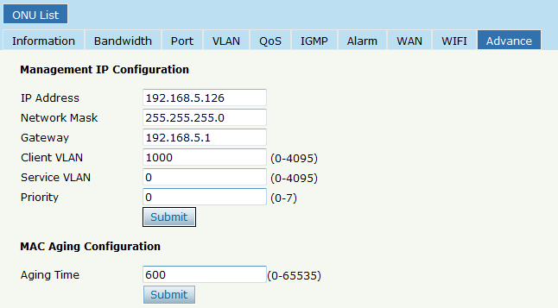

Figure 4-13 Advance

#### 4.1.1.12 VoIP

VoIP ONU can set the VoIP global parameter.

**ONU List 🡪 Config 🡪VoIP,** shown as Figure 4-14.

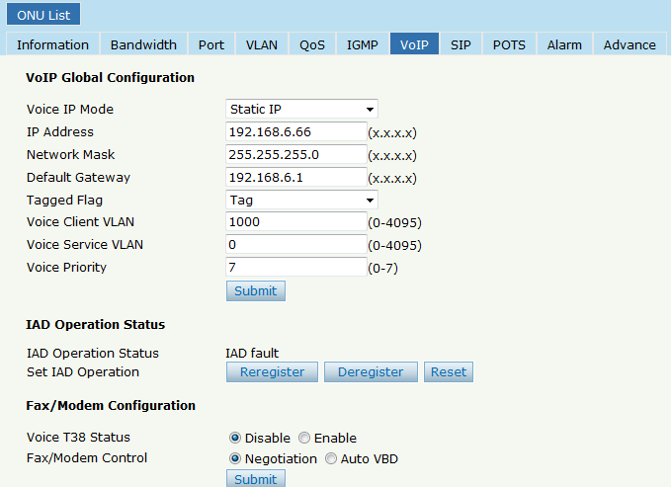

Figure 4-14 VoIP Global

#### 4.1.1.13 SIP

VoIP ONU SIP parameter can be set in this page.

**ONU List 🡪 Config 🡪SIP,** shown as Figure 4-15.

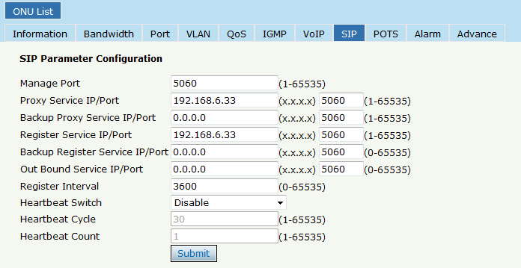

Figure 4-15 SIP Parameter

#### 4.1.1.14 POTS

VoIP ONU POTS account and password set in this page, the length can't be more than 16 bits.

**ONU List 🡪 Config 🡪POTS,** shown as Figure 4-16.

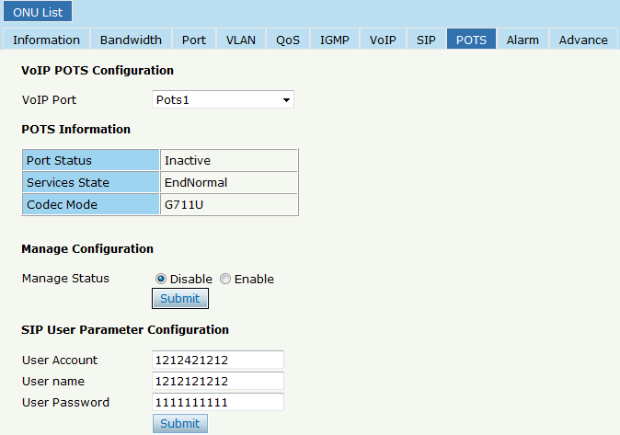

Figure 4-16 POTS Setting

### 4.1.2 Profile

All the profile are shown in this page, choose the suitable profile binding the ONU. Click **ONU Configuration🡪ONU List🡪Profile,** shown as Figure 4-17.

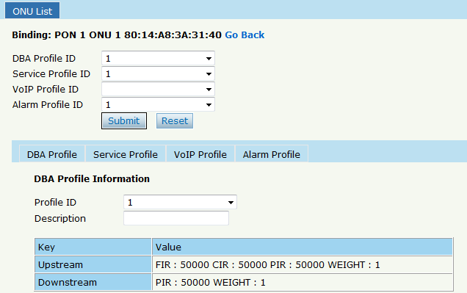

Figure 4-17 Profile Bind

### 4.1.3 Deregister Reset Unauth

Single ONU can be operated deregister, reset(reboot), unauth. And the same PON ONU can be operated batch. Click **ONU Configuration🡪ONU List,** shown as Figure 4-18.

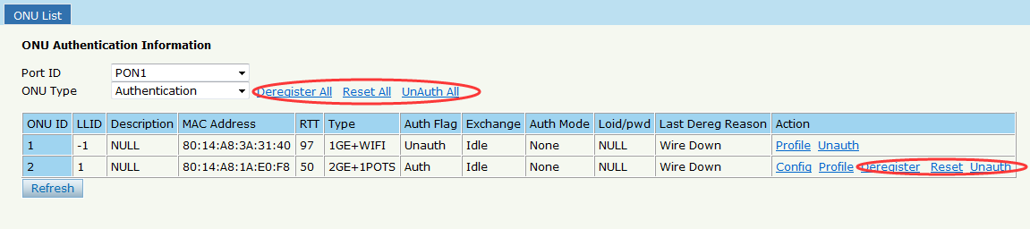

Figure 4-18 Deregister Reset Unauth Setting

### 4.1.4 ONU Status

Showing about the ONU information of the activity. User can check "Last Register Time" ,"Last Deregister Reason", "Active Time" for each ONU.

Click **ONU Configuration****🡪ONU List🡪ONU Status,** shown as Figure 4-19.

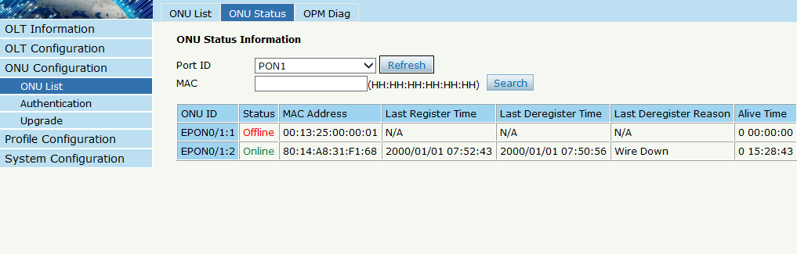

Figure 4-19 ONU Status

### 4.1.5 OPM Diag

Check the ONU RX power, a batch of ONU RX power information can be shown in a list. Clearly to check the register power, when register issue happen. Click **ONU Configuration🡪ONU List🡪OPM Diag,** shown as Figure 4-20.

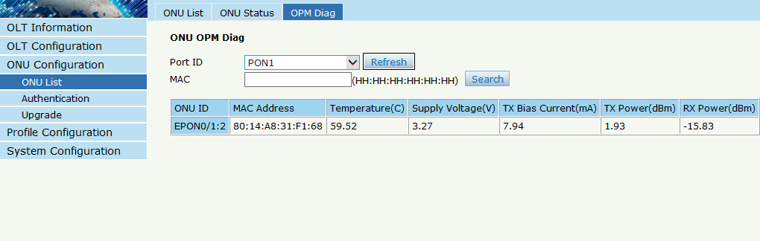

Figure 4-20 OPM Diag

## 4.2 Authentication

### 4.2.1 Authentication Mode

Authentication mode is basic on PON, it is "Disable" mode by default. There are 4 modes of the ONU authentication: Disable mode, MAC mode, LOID mode and Hybrid mode. Click **ONU Configuration🡪Authentication** **🡪 Authentication Mode,** shown as Figure 4-21

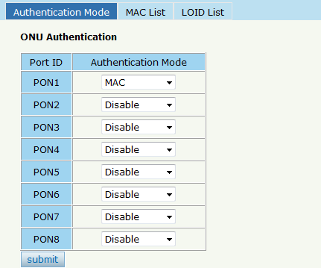

Figure 4-21 Authentication Mode

### 4.2.2 MAC list

When the ONU authentication mode is MAC mode, only ONUs with their MAC on the white list can register to the OLT. The black MAC list ONU cannot register whatever the mode.

Click **ONU Configuration🡪Authentication🡪MAC List,** shown as Figure 4-22.

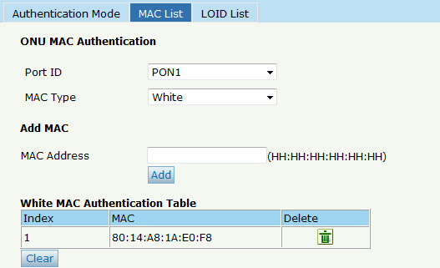

Figure 4-22 MAC List

### 4.2.3 LOID List

When the authentication mode is LOID, only the ONUs on the LOID list can register to the OLT. Click **ONU Configuration🡪Authentication🡪LOID List,** shown as Figure 4-23..

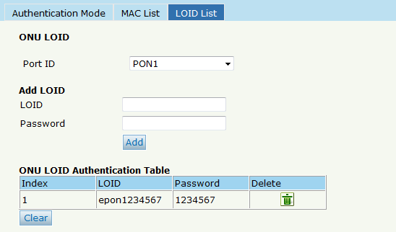

Figure 4-23 LOID List

## 4.3 Upgrade

ONU upgrade by OLT

### 4.3.1 Upgrade Status

When ONU is upgrading, the list will be shown in this page.

Click **ONU Configuration🡪Upgrade🡪Upgrade Status,** shown as Figure 4-24.

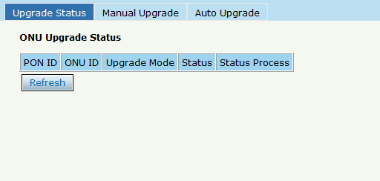

Figure 4-24 ONU Upgrade Status

### 4.3.2 Manual Upgrade

Choose the ONU which need to upgrade, select the ONU(fill in the ONU ID),browse the firmware ,click upgrade will be OK.

Click **ONU Configuration🡪Upgrade🡪Manual Upgrade,** shown as Figure 4-25.

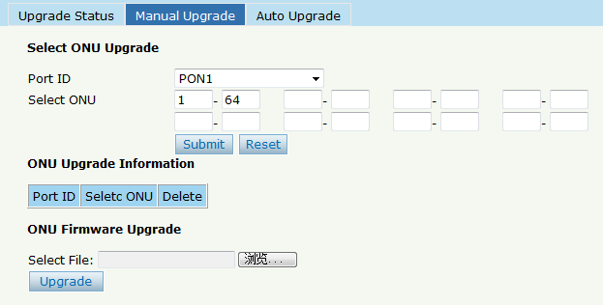

Figure 4-25 Manual Upgrade

### 4.3.3 Auto Upgrade

The ONU firmware will be saved in the OLT first, when the ONU come online, it will auto upgrade the firmware.

Click **ONU Configuration🡪Upgrade🡪Auto Upgrade,** shown as Figure 4-26.

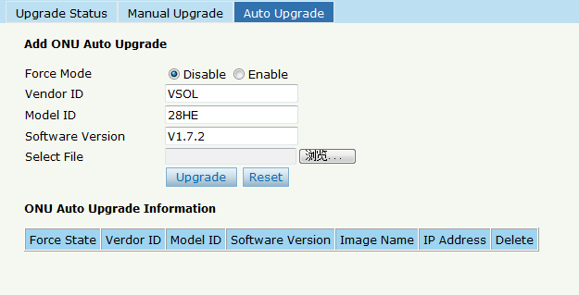

Figure 4-26 Auto Upgrade

# Chapter 5 Profile Configuration

This chapter is about the ONU profile configuration. It is designed for batch ONU management by OLT.

## 5.1 DBA Profile

All the ONU will be bound an default DBA profile. When the user bind manually, the new template will take effect.

### 5.1.1 Add/Commit

Add a DBA profile first, Click **Profile Configuration🡪DBA Profile 🡪 Add/Commit,** shown as Figure 5-1.

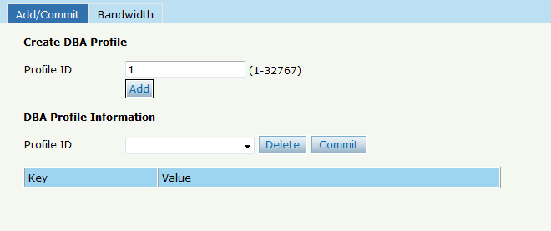

Figure 5-1 Add/Commit DBA Profile

### 5.1.2 Bandwidth

Select the DBA profile ID, configure the content of DBA. Click **Profile Configuration🡪DBA Profile 🡪 Add/Bandwidth,** shown as Figure 5-2.

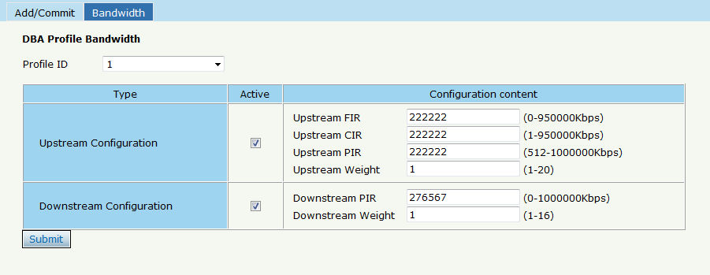

Figure 5-2 Bandwidth Content

## 5.2 Service Profile

The ONU service configuration can be set as a profile.

### 5.2.1 Add/Commit

Add a service profile ID first, Click **Profile Configuration🡪Service Profile 🡪 Add/Commit,** shown as Figure 5-3.

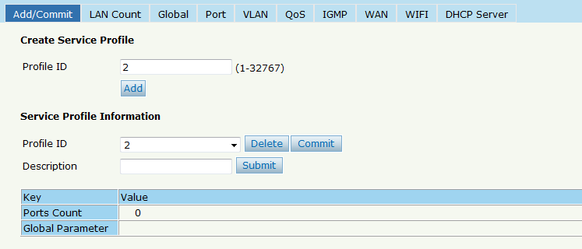

Figure 5-3 Add/Commit Service Profile

### 5.2.2 Content

The server profile configuration contain **LAN Conut, Global(MAC Age time), Port, VLAN, QoS, IGMP, WAN , WIFI, DHCP Server** etc.

Click **Profile Configuration🡪Service Profile**

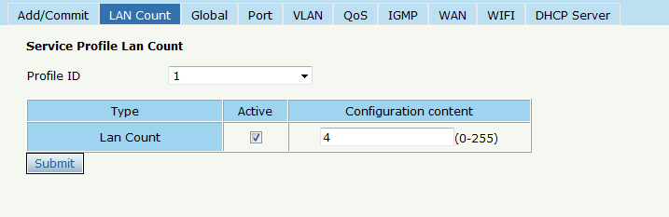

Figure 5-4 LAN Count

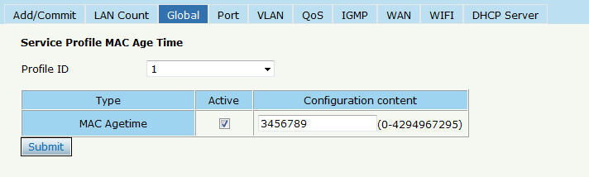

Figure 5-5 Global

## 5.3 VoIP Profile

The VoIP ONU can use this profile.

### 5.3.1 Add/Commit

Add a VoIP profile ID first, Click **Profile Configuration🡪VoIP Profile 🡪 Add/Commit,** shown as Figure 5-6.

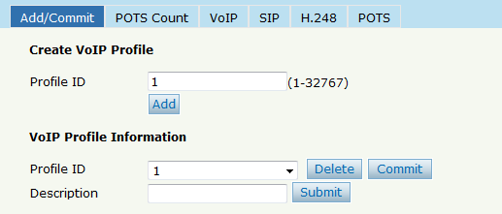Figure 5-6 Add/Commit VoIP Profile

### 5.3.2 Content

The VoIP profile configuration contain **POTS Count, VoIP, SIP, H.248, POTS** etc. Click **Profile Configuration🡪VoIP Profile.**

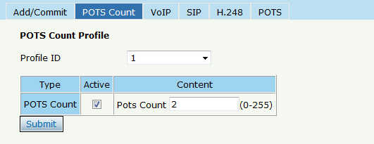

Figure 5-7 POTS Count

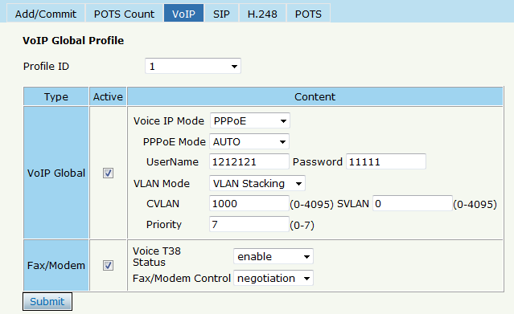

Figure 5-8 VoIP

## 5.4 Alarm Profile

### 5.4.1 Add/Commit

Add a alarm profile ID first, Click **Profile Configuration🡪Alarm Profile 🡪 Add/Commit,** shown as Figure 5-9.

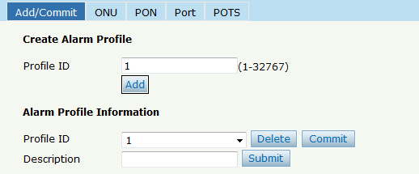

Figure 5-9 Add/Commit Alarm Profile

### 5.4.2 Content

The alarm profile contains **ONU global threshold alarm, PON alarm, Port alarm, POTS alarm, etc.** Click **Profile Configuration🡪Alarm Profile.**

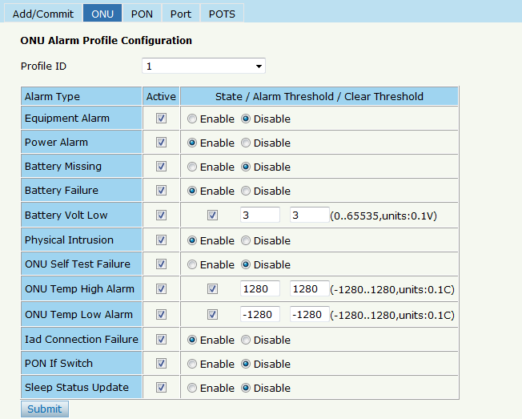

Figure 5-10 ONU Global Alarm

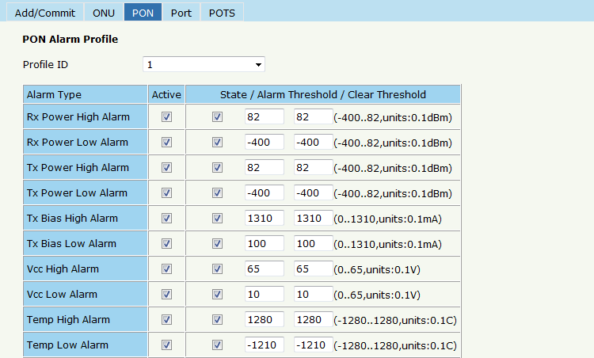

Figure 5-11 PON Alarm

## 5.5 Bind Profile

The DBA profile, server profile, VoIP profile, alarm profile can be bound to the ONU.

### 5.5.1 Information

In this page, the ONU profile bind list will be shown, and configure the ONU profile by click the "Config", Click **Profile Configuration🡪Bind Profile🡪Information.**

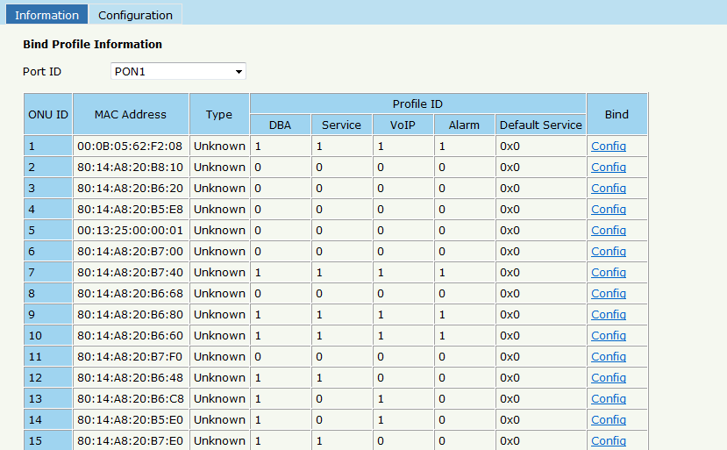

Figure 5-12 Bind Profile Information

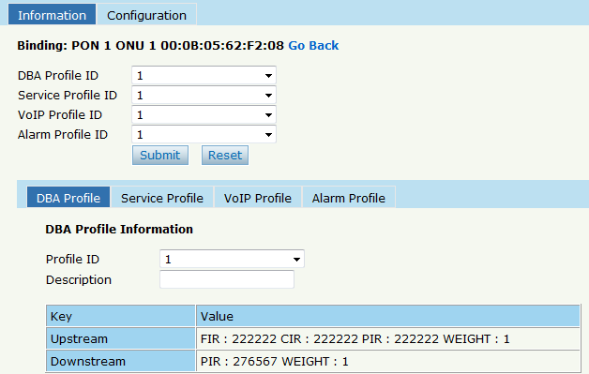

Figure 5-13 Config

### 5.5.2 Configuration

In this page, the ONU list about the profile binding will be show, batch to bind the profile can be allowed. Click **Profile Configuration🡪Bind Profile🡪Configuration.**

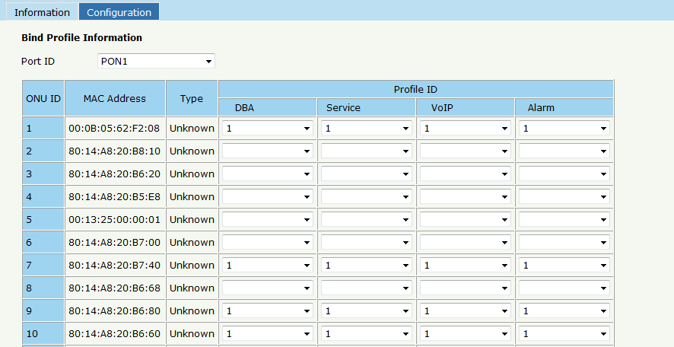

Figure 5-14 Bind Profile Configuration

# Chapter 6 System Configuration

This chapter is about the global management of OLT.

## 6.1 System Log

### 6.1.1 System Log

Click **System Configuration**🡪**System Log** to view system event and alarm information.

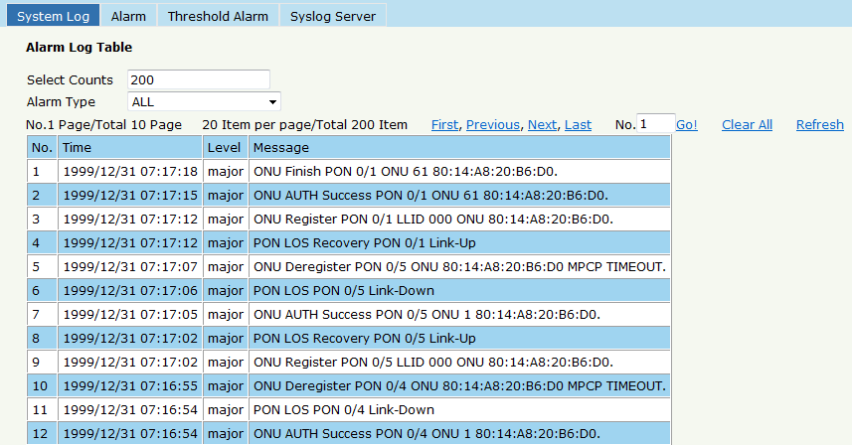

Figure 6-1 System Log

The events and alarms levels are listed in Table 2-1.

Table 2-1 Event and Alarm level

|  |  |  |  |  |  |
| --- | --- | --- | --- | --- | --- |
| ITEM | DESCRIPTION | LEVEL | ITEM | DESCRIPTION | LEVEL |
| ALARM | OLT Port Up down | warning | EVENT | System Config Save | warning |
| OLT Port Loopback | warning | System Config Erase | warning |
| OLT Temp High | major | Download File Success | major |
| OLT Temp Low | major | Upload File Success | major |
| OLT CPU Usage High | major | Upgrade File Success | major |
| OLT MEM Usage High | major | PON Register | critical |
| OLT FAN | major | PON Enable | major |
| Download File Failed | major | PON LOS Recovery | major |
| Upload File Failed | major | ONU is Registering | major |
| Upgrade File Failed | major | ONU Link Discover | major |
| PON Disable | major | ONU AUTH Success | major |
| PON TX Power High | major | ONU DEAUTH Success | major |
| PON TX Power Low | major | ONU Upgrade Over | major |
| PON TX Bias High | major | ONU finish the register and AUTH | major |
| PON TX Bias Low | major | System Reset | critical |
| PON VCC High | major |  |  |  |
| PON VCC Low | major |  |  |  |
| PON Temp High | major |  |  |  |
| PON Temp Low | major |  |  |  |
| PON LOS | major |  |  |  |
| ONU Deregister | major |  |  |  |
| ONU Link LOST | major |  |  |  |
| ONU Illegal Register | major |  |  |  |
| ONU AUTH Failed | major |  |  |  |
| ONU MAC Conflict | major |  |  |  |
| ONU LOID Conflict | major |  |  |  |
| ONU Critical Event | major |  |  |  |
| Dying Gasp | major |  |  |  |
| ONU Link Fault | major |  |  |  |
| ONU Link Event | major |  |  |  |
| ONU Event Notific | major |  |  |  |
| ONU Laser Always On | major |  |  |  |
| PON Deregister | critical |  |  |  |
| PON Register Failed | critical |  |  |  |

### 6.1.2 Alarm

It contains all the alarms of OLT. User can choose the different alarms to "**Print**", "**Record**", "**Trap**" and "**Remote**". Click **System Configuration** 🡪 **System Log** 🡪**Alarm.**

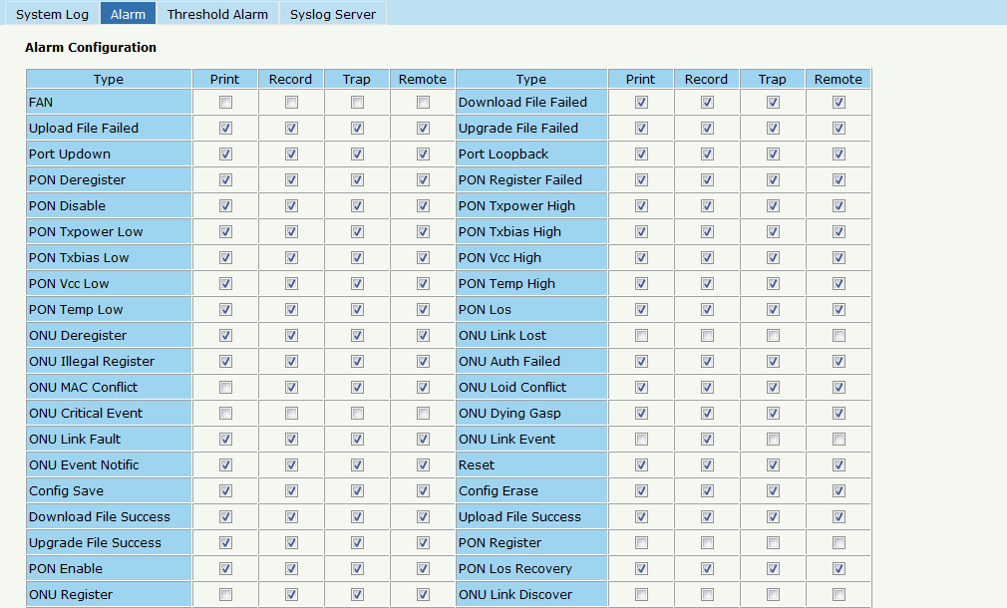

Figure 6-2 Alarm

### 6.1.3 Threshold Alarm

Configure the temperature threshold, CPU-usage threshold and memory- usage threshold, PON optical threshold. Click **System Configuration** 🡪 **System Log** 🡪**Threshold** **Alarm.**

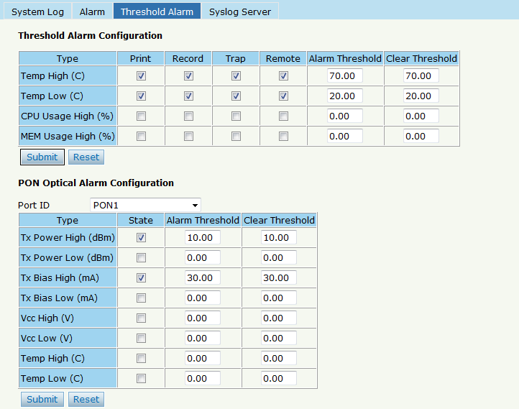

Figure 6-3 Threshold Alarm

### 6.1.4 Syslog Server

Configure the server of OLT remote system logs. Click **System Configuration**🡪 **System Log** 🡪**Syslog Server.**

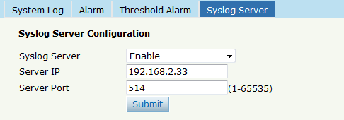

Figure 6-4 Syslog Server

## 6.2 Device Management

### 6.2.1 Firmware Upgrade

You can upgrade the OLT firmware by WEB, do not need TFTP server. After finish upgrading, it will ask if you want to reboot OLT. It need to reboot after upgrade then take effect. Click **System Configuration**🡪 **Device Management** 🡪**Firmware Upgrade.**

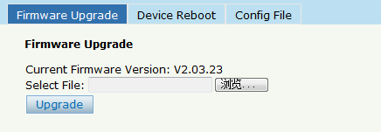

Figure 6-5 Firmware Upgrade

### 6.2.2 Device Reboot

Click **System Configuration**🡪 **Device Management** 🡪**Device Reboot**, it will reboot the entire system.(Please save the configuration first)

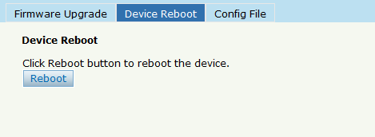

Figure 6-6 Device Reboot

### 6.2.3 Config File

Click **System Configuration**🡪 **Device Management** 🡪 **Config File**, you can backup configuration, restore configuration, restore factory defaults and save configuration.

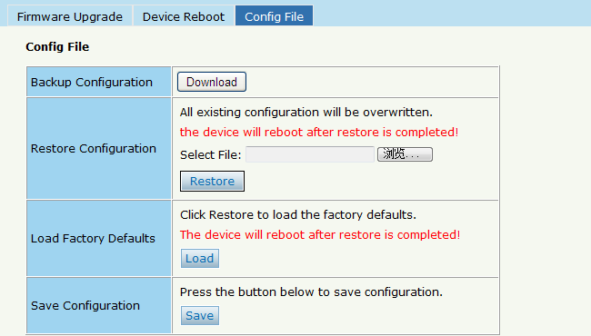

Figure 6-7 Config File

## 6.3 User Management

Two kinds of users have been defined, Normal and Admin. There are limitations to normal user, and admin user has no limits to full function of OLT. The default account member is **Admin** level.

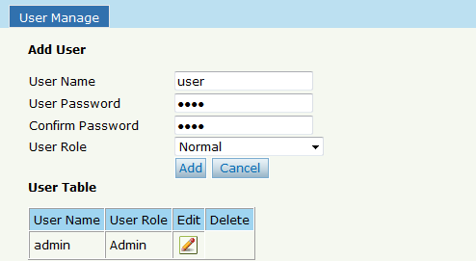

Figure6-8: User Manage

## 6.4 SNMP

### 6.4.1 SNMP V1/V2

The EPON OLT supports SNMP v1/v2,click **System Configuration 🡪 SNMP 🡪SNMP V1/V2** to configure.

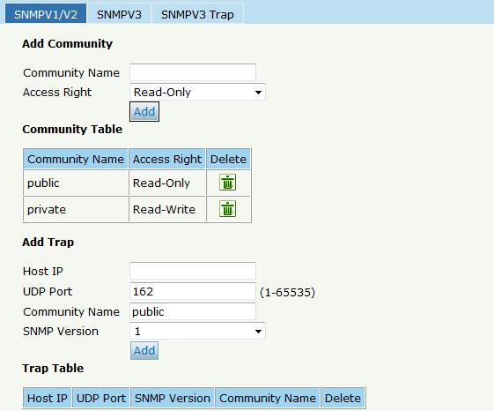

Figure6-9: SNMP V1/V2

### 6.4.2 SNMP V3

The EPON OLT also supports SNMP V3, click **System Configuration 🡪 SNMP 🡪SNMP V3,** as shown in Figure 6-10.

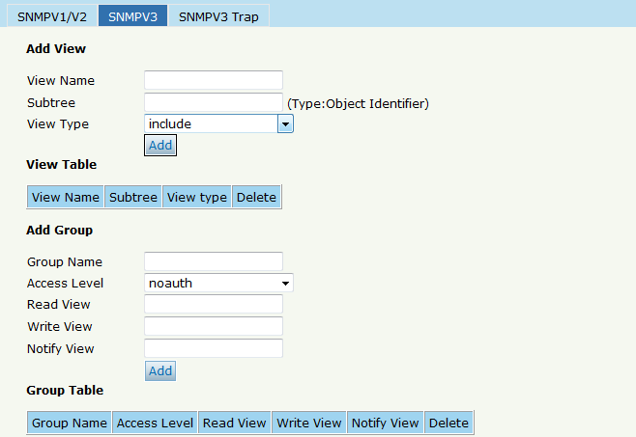

Figure 6-10: SNMP V3

### 6.4.3 SMNP V3 Trap

Configure or remove the Trap messages of the target host IP address.

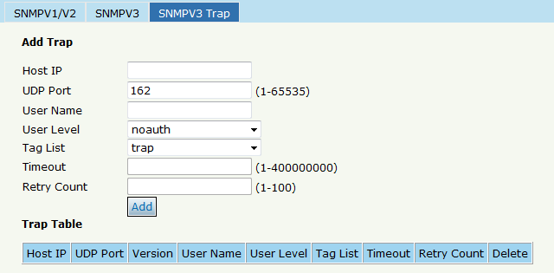

Figure 6-11: SNMP V3 Trap

## 6.5 AUX IP

AUX port is out band management port. The IP address is out band management IP, default IP address is 192.168.8.100. User can change it if need. Click **System Configuration 🡪 AUX IP**

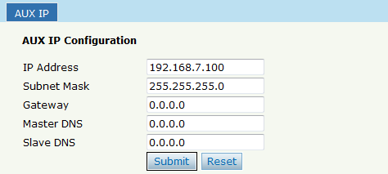

Figure 6-12: AUX IP

## 6.6 System Time

### 6.6.1 RTC

Click **System Configuration 🡪 System Time🡪RTC** .The default system time is the OLT firmware release time.

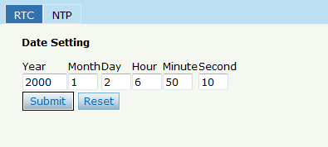

Figure 6-13: RTC Configuration

### 6.6.2 NTP

Synchronize the time to the NTP server. Click **System Configuration 🡪 System Time🡪NTP**

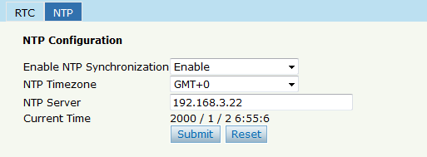

Figure 6-14: NTP Configuration

## 6.7 FAN

The fans can be controlled to turn on/off, or turn on automatically.

Click **System Configuration 🡪 FAN.**

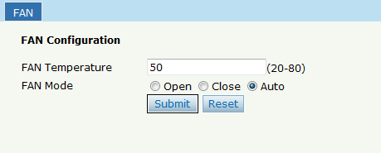

Figure 6-15: FAN Configuration

## 6.8 Mirror

Each monitor session can be set with one destination port and up to 8 source ports. Click **System Configuration 🡪 Mirror.**

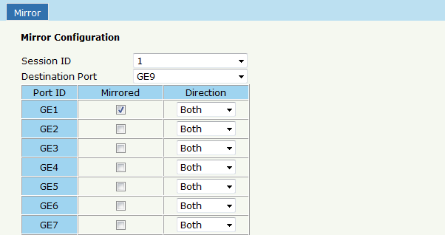

Figure 6-16: Mirror

# Chapter 7 Configuration Examples

## 7.1 Internet With VLAN 100

a. OLT configuration

Step 1: Create a new VLAN.

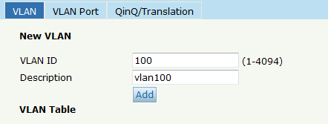

Step 2: Add the VLAN to GE port and PON port.

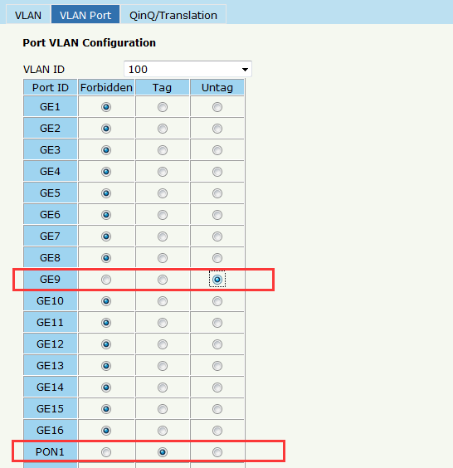

Step 3: Configure the default VLAN ID (PVID) in untag port.

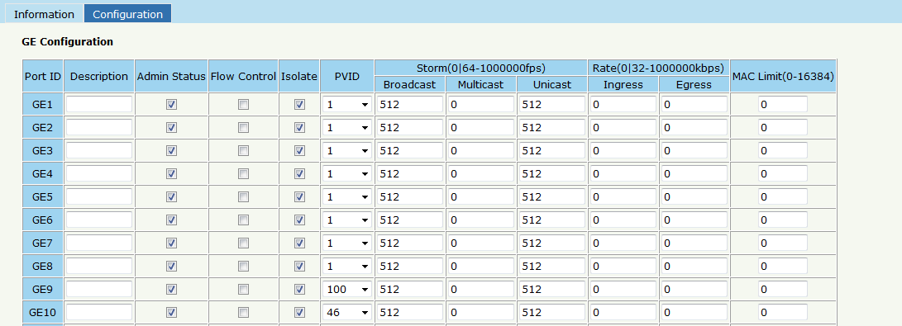

b. ONU configuration

Step 4: Choose the VLAN mode and set the PVID value.

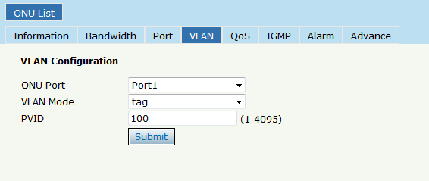

## 7.2 IPTV With VLAN 200

a. OLT configuration

Step 1: Create a new VLAN.

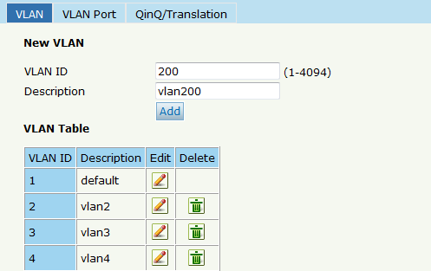

Step 2:Add the VLAN to GE port and PON port.

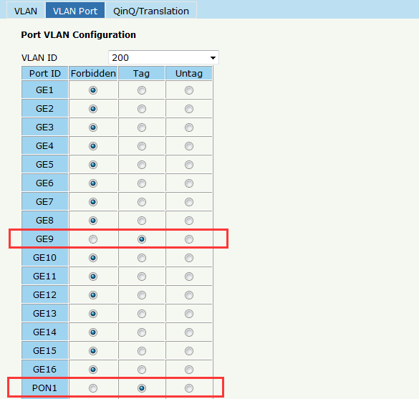

Step 3: Enable the IGMP status.

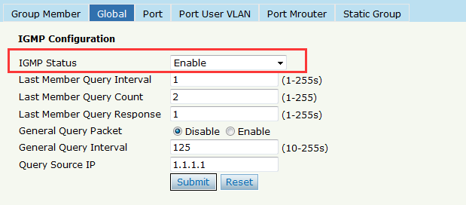

Step 4: Add the IGMP user VLAN and group VLAN

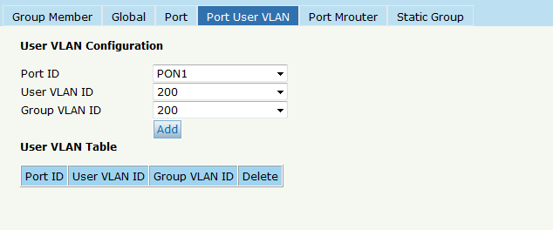

Step 5: Add the M-router in GE port

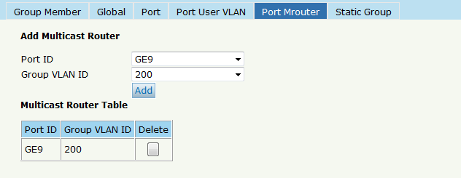

b. ONU configuration

Step 6: Choose the VLAN mode and set the PVID value.

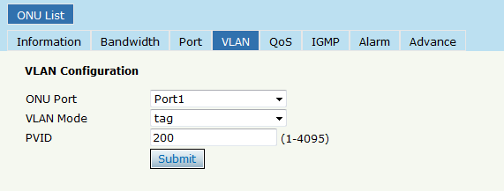

Step 7: Configuration multicast VLAN

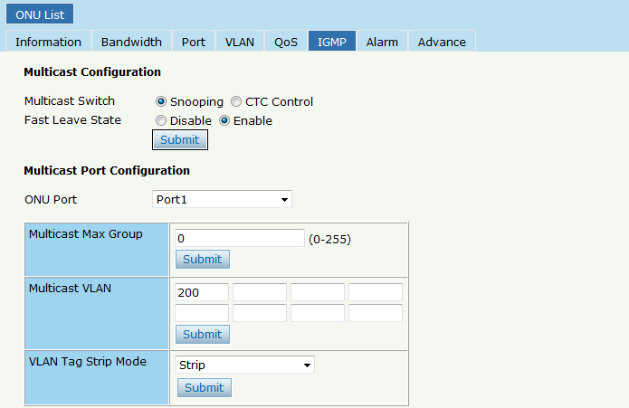

## 7.3 VoIP With VLAN 300

a. OLT Configuration

Step 1: Create a new VLAN

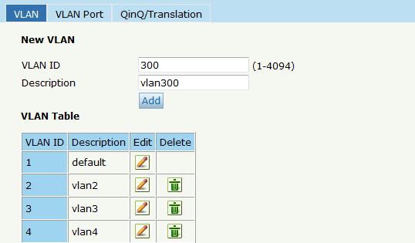

Step 2: Add the VLAN to GE port and PON port.

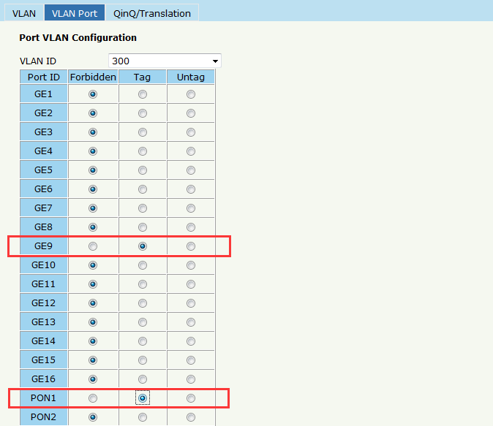

b. ONU Configuration

Step 3: Configure the VoIP global parameter

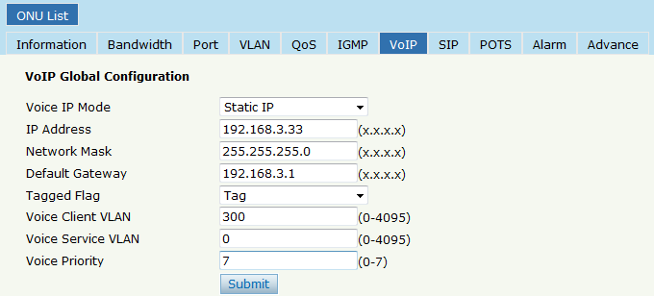

Step 4: Setup the SIP configuration

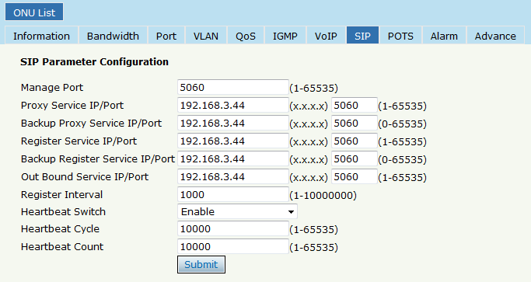

Step 5: Fill in the user account and password

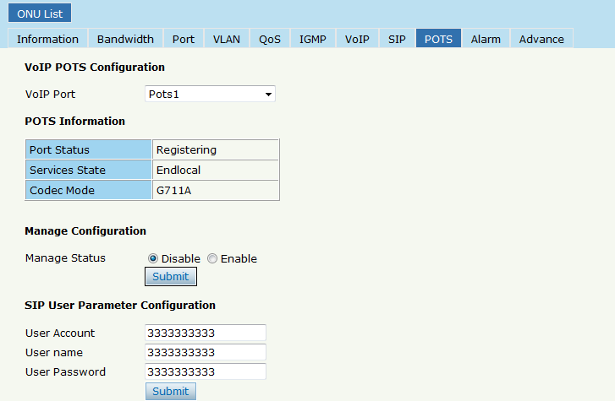

**Thank you!**