**Set onu firmwall and change password**

**Model：1GE+WiFi/1GE+1FE+WiFi/1GE+1FE+WiFi+Catv/4Lan+WiFi EPON**

Step1: use the labtop/pc local interface connect to onu any Lan port directly with network cable.

Step2: set the labtop/pc local interface ip address to 192.168.1.100 mask 255.255.255.0

Step3：try to ping 192.168.1.1 in your labtop/pc, make sure it can ping to onu. Then operate the next following steps.

Step4: set the firewall in **High level.** And **change your onu password.**

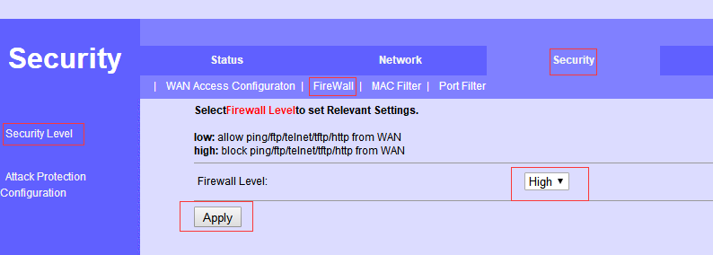

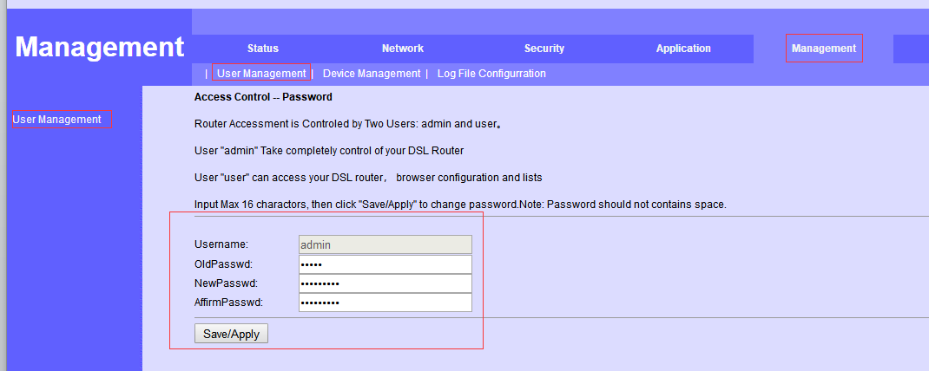

**Model： 2Lan+Pots+WiFi/4Lan+2Pots+WiFi**

Step1: use the labtop/pc local interface connect to onu any Lan port directly with network cable.

Step2: set the labtop/pc local interface ip address to 192.168.1.100 mask 255.255.255.0

Step3：try to ping 192.168.1.1 in your labtop/pc, make sure it can ping to onu. Then operate the next following steps.

Step4: set the firewall in **High level,** **disable the WAN access** , **change your onu password.**

