**OLT CLI upgrade guide**

Step1: Connect PC to OLT AUX port.

OLT AUX port default management ip 192.168.8.100.

Config PC IP 192.168.8.101 255.255.255.0

Step2:Running TFTP server tool. Select the firmware files directory.

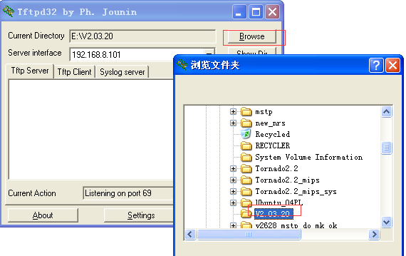

Step3:Upgrade OLT firmware(img and ubi or bin files)

Login: **admin**

Password: **admin**

epon-olt> **enable**

Password: **admin**

epon-olt# **config terminal**

epon-olt(config)# **download tftp image V1600D_IMG_V2.03.20.img 192.168.8.101**

epon-olt(config)# **download tftp image V1600D_UBI_V2.03.20.ubi 192.168.8.101**

or（some old olt firmware in debug mode upgrade firmware）

OLT(config)# **debug mode**

OLT(debug-mode)# **download tftp image V1600D_IMG_V2.03.20.img 192.168.8.101**

OLT(debug-mode)# **download tftp image V1600D_UBI_V2.03.20.ubi 192.168.8.101**

**for example:**

epon-olt(config)# download tftp image V1600D_IMG_V2.03.20.img 192.168.8.101

Trying to download V1600D_IMG_V2.03.20.img from server 192.168.8.101, please wait...

2000/01/01 22:57:07 Download File Success download V1600D_IMG_V2.03.20.img success

Image file V1600D_IMG_V2.03.20.img is kernel

Erase flash mtd /dev/mtd2

Trying to save to flash,len = 0x5b82c4, mtd size 0xd00000 please wait...

................................................................

................................................................

................................................................

................................................................

................................................................

..............................................

Save to flash success...

2000/01/01 22:57:10 Upgrade File Success upgrade V1600D_IMG_V2.03.20.img success

epon-olt(config)# download tftp image V1600D_UBI_V2.03.20.ubi 192.168.8.101

Trying to download V1600D_UBI_V2.03.20.ubi from server 192.168.8.101, please wait...

2000/01/01 22:58:43 Download File Success download V1600D_UBI_V2.03.20.ubi success

Image file V1600D_UBI_V2.03.20.ubi is rootfs

Erase flash mtd /dev/mtd4

Trying to save to flash,len = 0x27e0000, mtd size 0x4000000 please wait...

................................................................

................................................................

................................................................

................................................................

................................................................

................................................................

................................................................

................................................................

................................................................

................................................................

................................................................

................................................................

................................................................

................................................................

................................................................

................................................................

................................................................

................................................................

................................................................

................................................................

................................................................

................................................................

................................................................

........................................................

Save to flash success...

2000/01/01 22:58:57 Upgrade File Success upgrade V1600D_UBI_V2.03.20.ubi success

Step4: save configuration (if necessary) and reboot olt.

epon-olt(config)# **copy running-config startup-config**

2000/01/01 23:01:52 System Config Save save config by command

Configuration saved to /mnt/custfs/usrcfg.conf

epon-olt(config)# reboot

Are you sure want to reboot system? [Y/N]y