OLT CLI upgrade guide
Step1: Connect PC to OLT AUX port.
OLT AUX port default management ip 192.168.8.100.
Config PC IP 192.168.8.101 255.255.255.0

Step2:Running TFTP server tool. Select the firmware files directory.
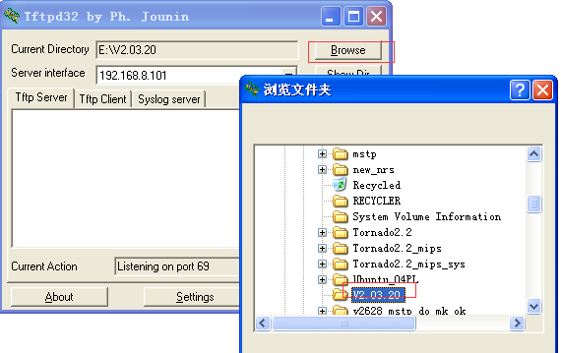

Step3:Upgrade OLT firmware(img and ubi or bin files)
Login: admin
Password: admin
epon-olt> enable
Password: admin
epon-olt# config terminal

epon-olt(config)# download tftp image V1600D_IMG_V2.03.20.img 192.168.8.101
epon-olt(config)# download tftp image V1600D_UBI_V2.03.20.ubi 192.168.8.101
or in some old olt firmware download like this:
epon-olt# config terminal
epon-olt(config)# debug mode
epon-olt(debug-mode)# download tftp image V1600D_IMG_V2.03.20.img 192.168.8.101
epon-olt(debug-mode)# download tftp image V1600D_UBI_V2.03.20.ubi 192.168.8.101

for example:
epon-olt(config)# download tftp image V1600D_IMG_V2.03.20.img 192.168.8.101
Trying to download V1600D_IMG_V2.03.20.img from server 192.168.8.101, please wait...
2000/01/01 22:57:07 Download File Success download V1600D_IMG_V2.03.20.img success
Image file V1600D_IMG_V2.03.20.img is kernel
Erase flash mtd /dev/mtd2
Trying to save to flash,len = 0x5b82c4, mtd size 0xd00000 please wait...
................................................................
................................................................
................................................................
................................................................
................................................................
..............................................
Save to flash success...
2000/01/01 22:57:10 Upgrade File Success upgrade V1600D_IMG_V2.03.20.img success

epon-olt(config)# download tftp image V1600D_UBI_V2.03.20.ubi 192.168.8.101
Trying to download V1600D_UBI_V2.03.20.ubi from server 192.168.8.101, please wait...
2000/01/01 22:58:43 Download File Success download V1600D_UBI_V2.03.20.ubi success
Image file V1600D_UBI_V2.03.20.ubi is rootfs
Erase flash mtd /dev/mtd4
Trying to save to flash,len = 0x27e0000, mtd size 0x4000000 please wait...
................................................................
................................................................
................................................................
................................................................
................................................................
................................................................
................................................................
................................................................
................................................................
................................................................
................................................................
................................................................
................................................................
................................................................
................................................................
................................................................
................................................................
................................................................
................................................................
................................................................
................................................................
................................................................
................................................................
........................................................
Save to flash success...
2000/01/01 22:58:57 Upgrade File Success upgrade V1600D_UBI_V2.03.20.ubi success

Step4: save configuration (if necessary) and reboot olt.
epon-olt(config)# copy running-config startup-config
2000/01/01 23:01:52 System Config Save save config by command
Configuration saved to /mnt/custfs/usrcfg.conf
epon-olt(config)# reboot
Are you sure want to reboot system? [Y/N]y

