Security Modification and Upgrade Guide

Take some models as examples, this document shows how to configure ONUs with different interfaces to improve security. If the model does not appear in the file, please configure it according to the ONU interface.

# 1 XPON 1GE

## Upgrade ONU

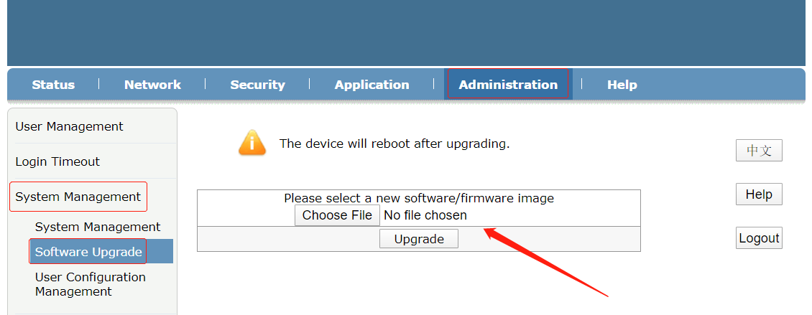

## Security Modification

1. Login ONU web (admin/admin)
2. Change the default password

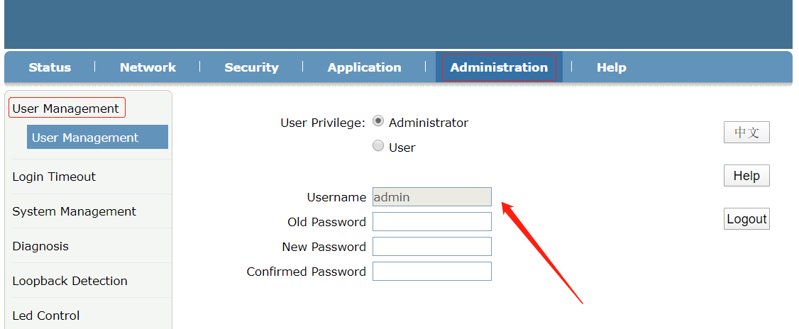

1. Disable the WAN access

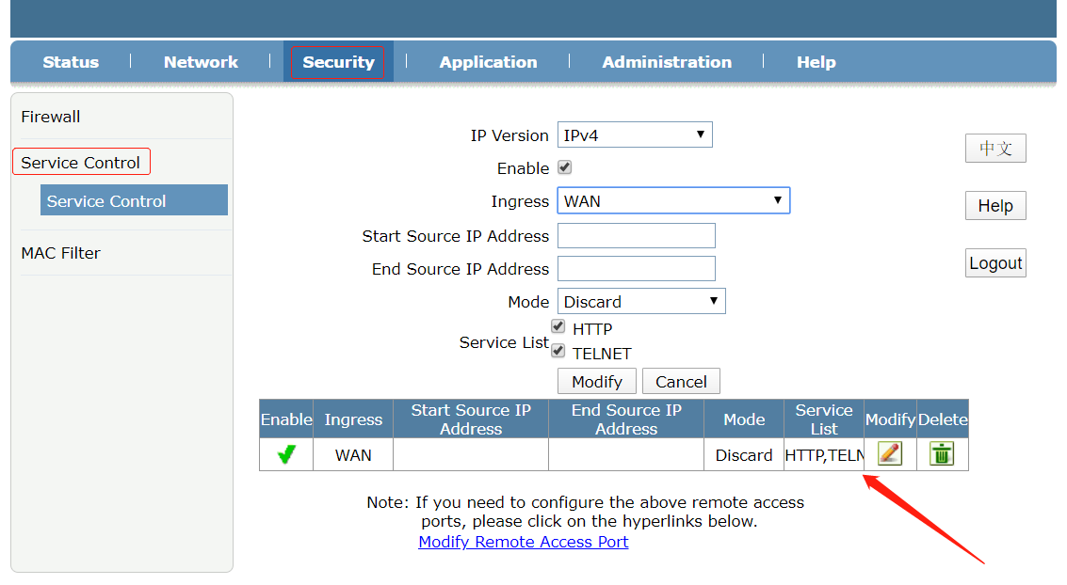

# 2 EPON 1GE+WIFi (Single antenna)/1GE+1FE+WiFi/1GE+1FE+WiFi+CATV

## Upgrade ONU

Upgrade ONU to the latest firmware first.

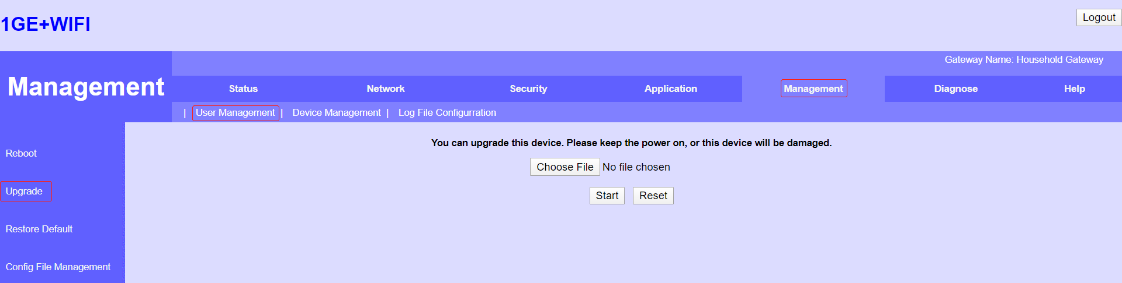

## Security Modification

1. Login ONU web (admin/admin or admin/stdONUi0i)
2. Change the default password

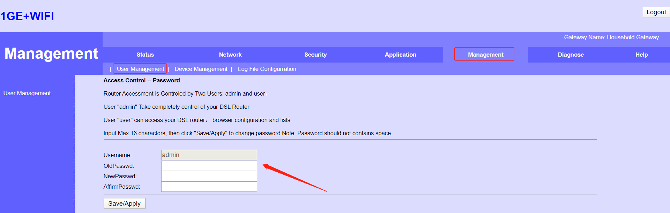

1. Set firewall to high, which will disable the WAN access

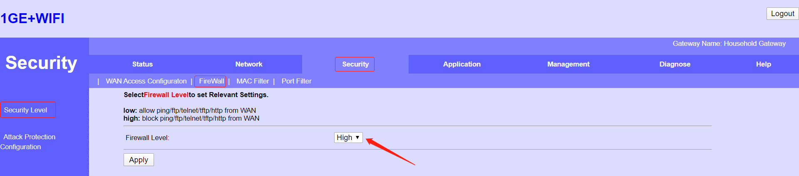

1. Enable attack protection

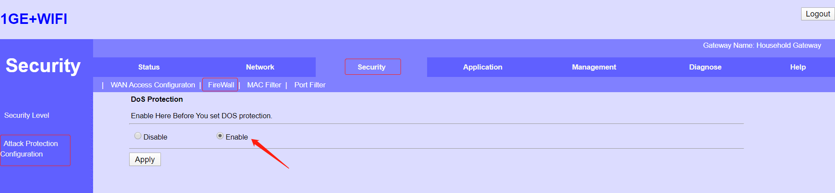

# 3 XPON 1GE+WIFi (Single antenna)/1GE+1FE+WiFI/1GE_1FE+WiFi+CATV

## Upgrade ONU

Upgrade ONU to the latest firmware first.

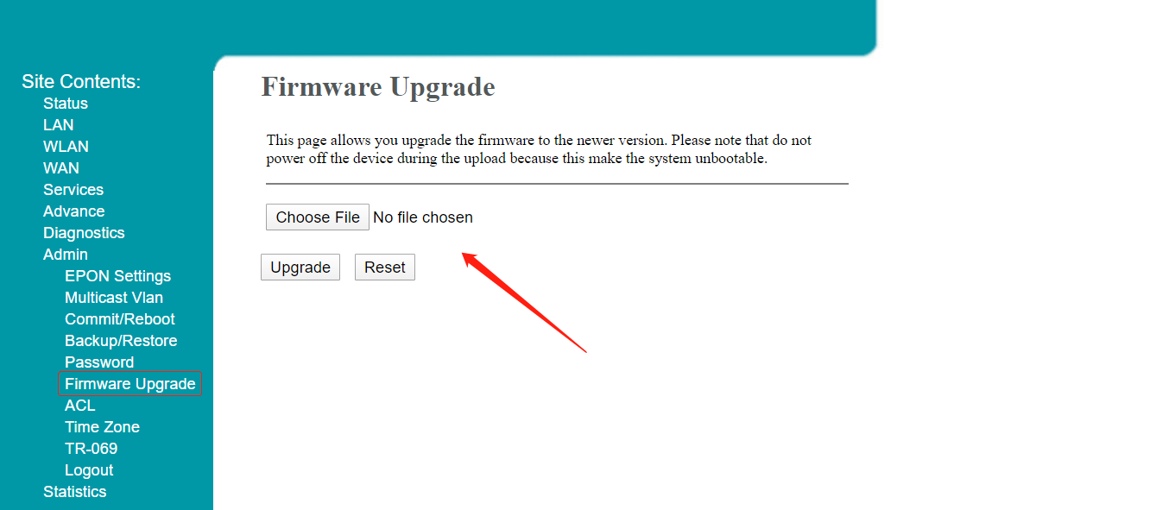

## Security Modification

1. Login ONU web (admin/stdONUi0i)
2. Change the default password

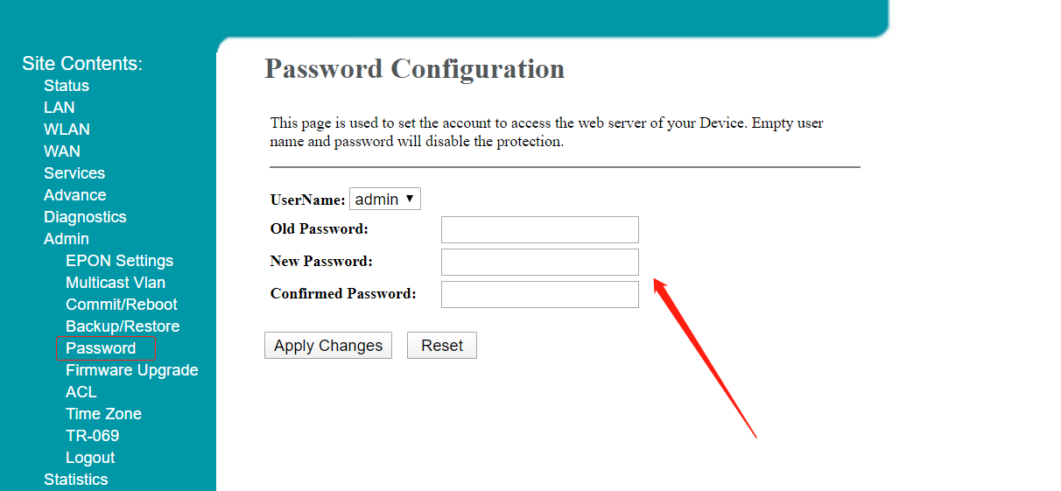

1. Set firewall to high

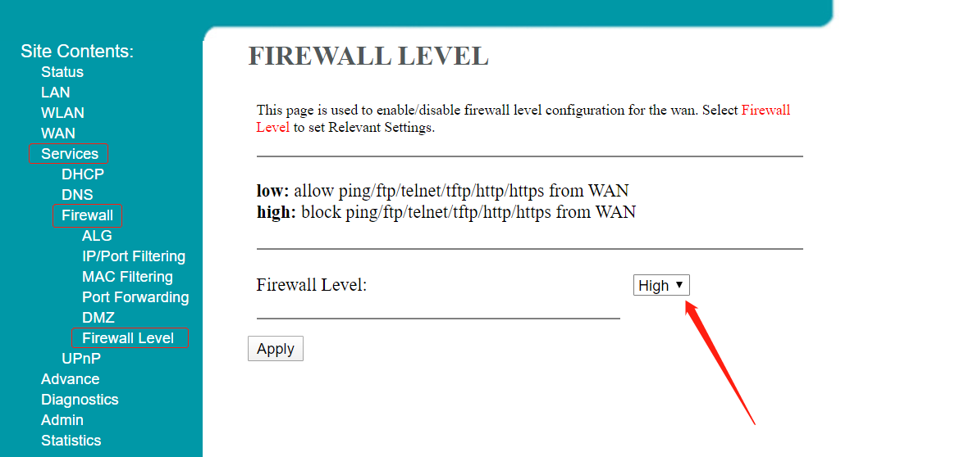

1. Disable the WAN access

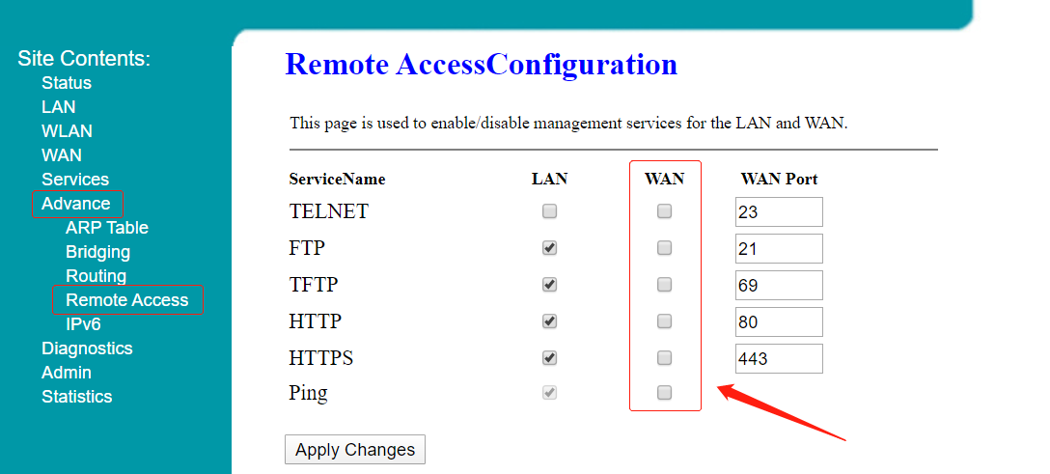

# 4 XPON 1GE+WIFi/2GE+1POTS+WiFi (Dual antenna)

## Upgrade ONU

Upgrade ONU to the latest firmware first.

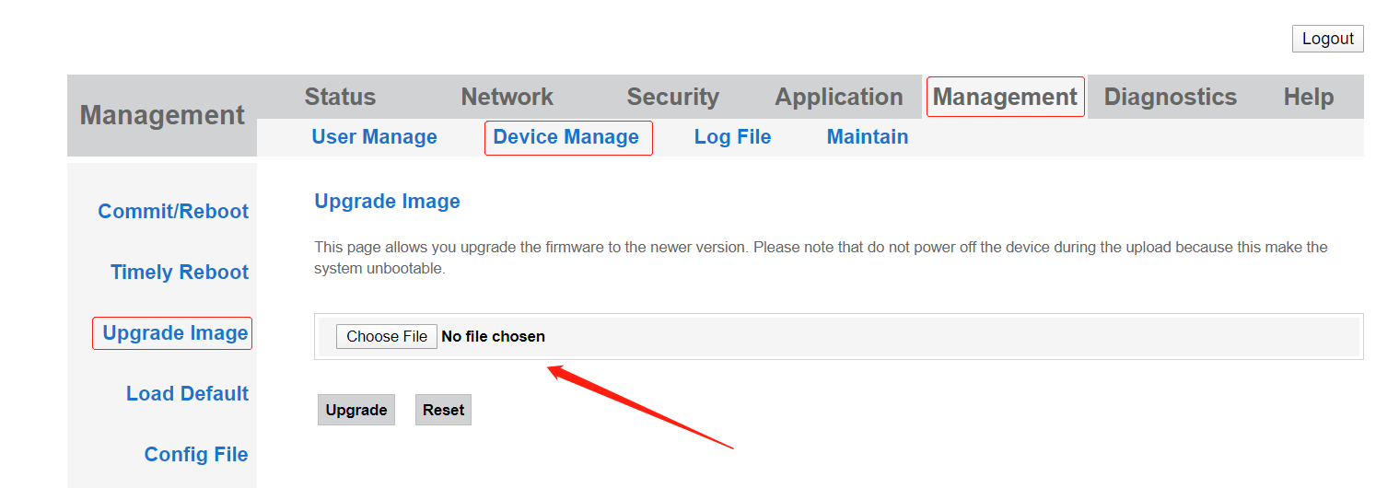

## Security Modification

1. Login ONU web (admin/stdONUi0i)
2. Change the default password

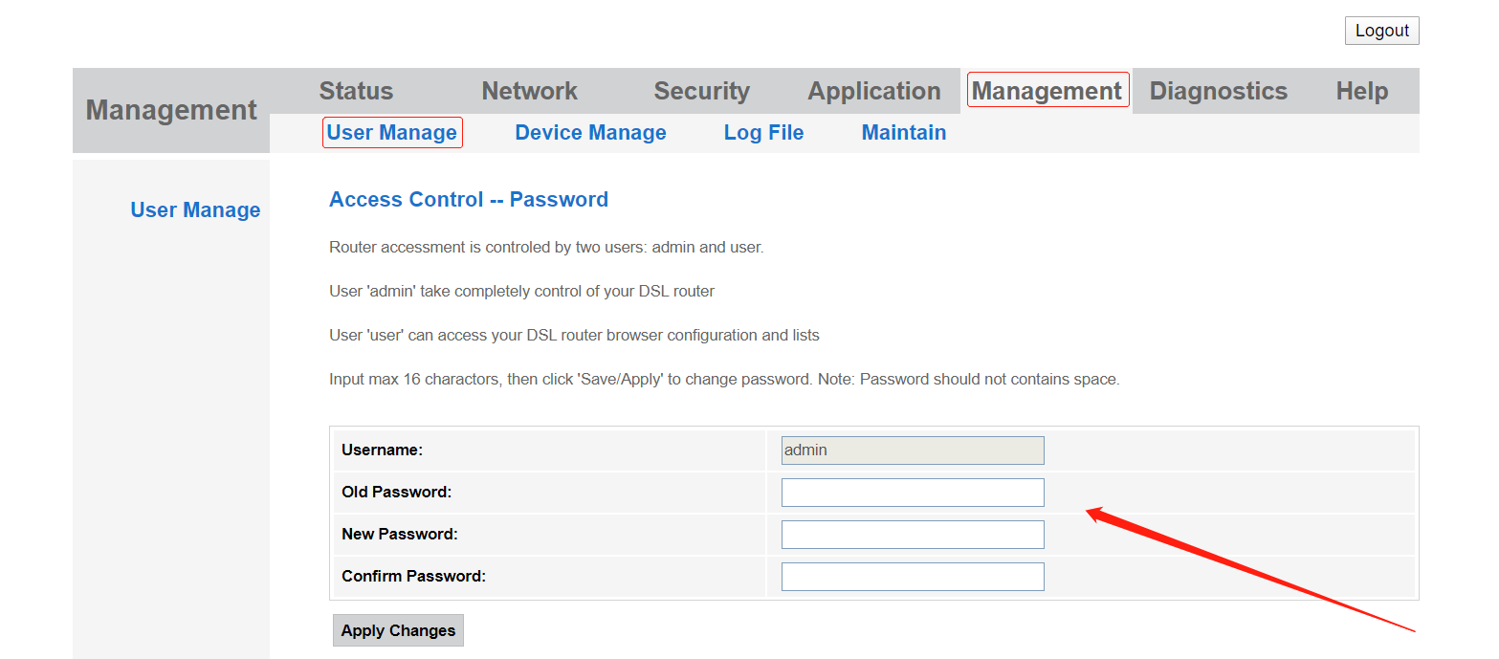

1. Set firewall to high

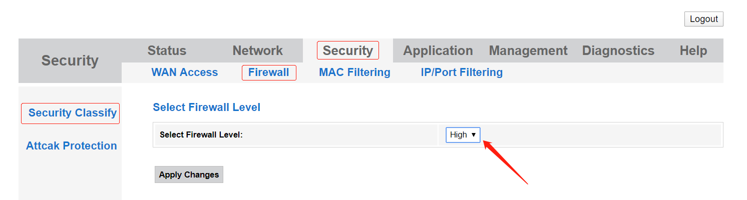

1. Disable the WAN access

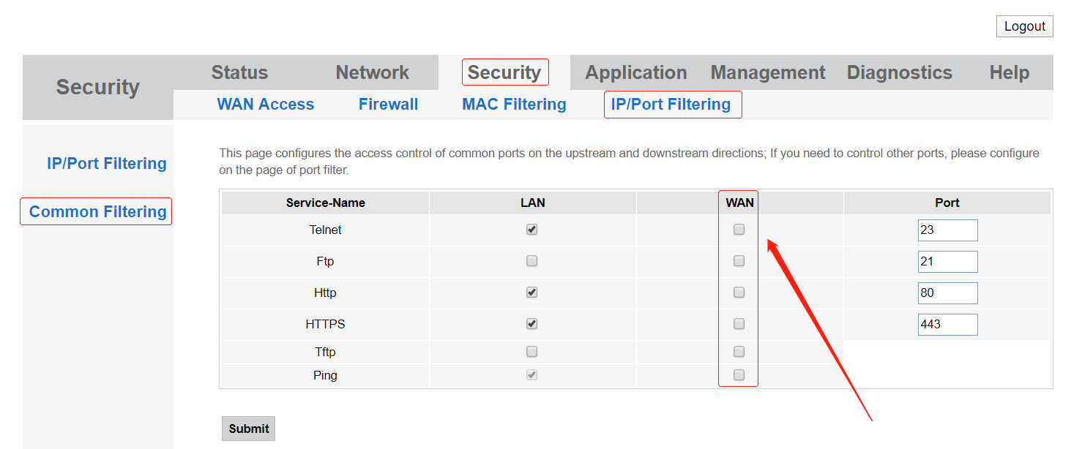

1. Enable attack protection

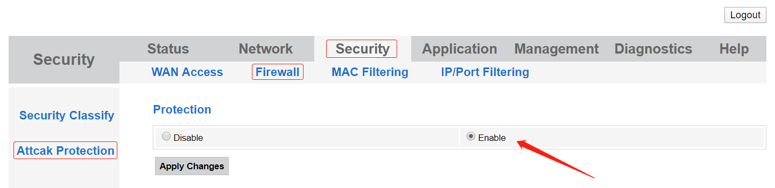

# 5 XPON 2LAN+1POTS+WiFi/4LAN+2POTS+WiFi

## Upgrade ONU

Upgrade ONU to the latest firmware first.

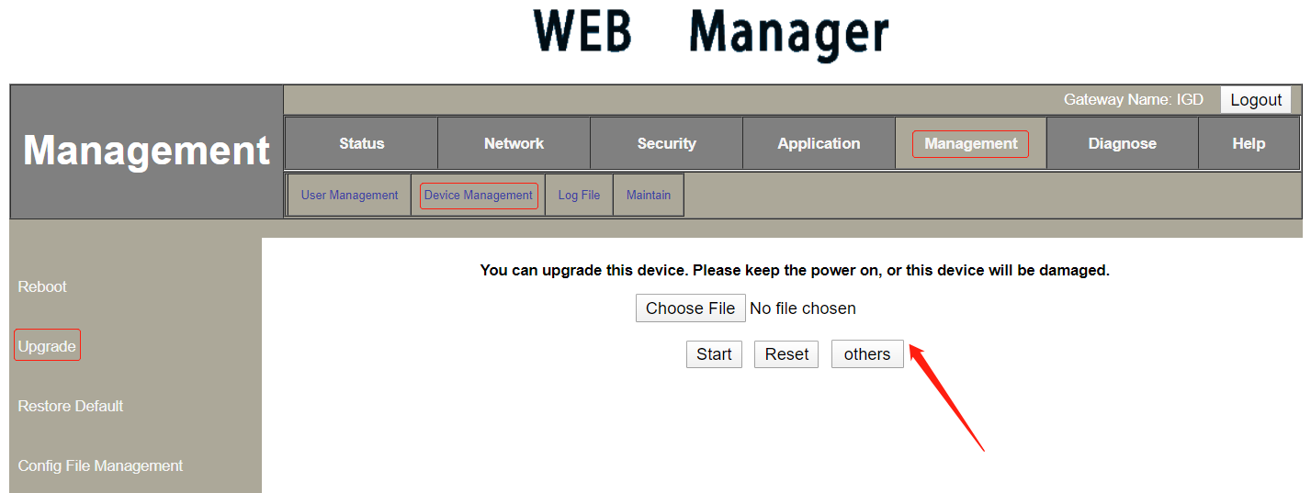

## Security Modification

1. Login ONU web (admin/stdONU101)
2. Change the default password

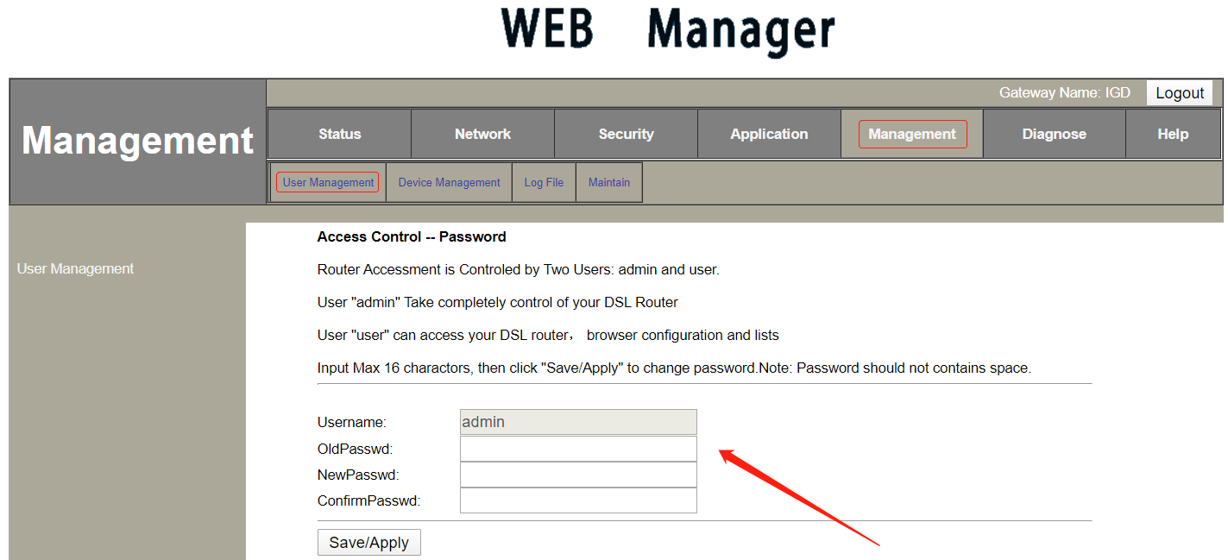

1. Set firewall to high

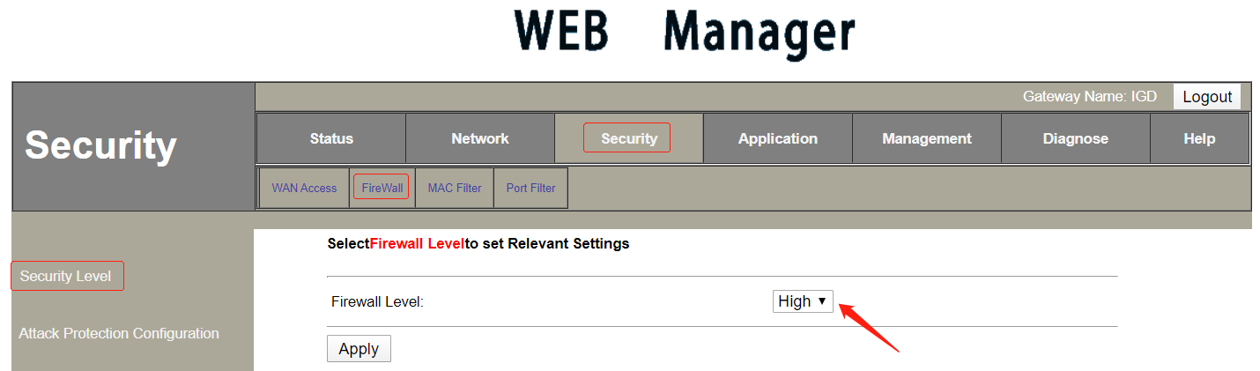

1. Disable the WAN access

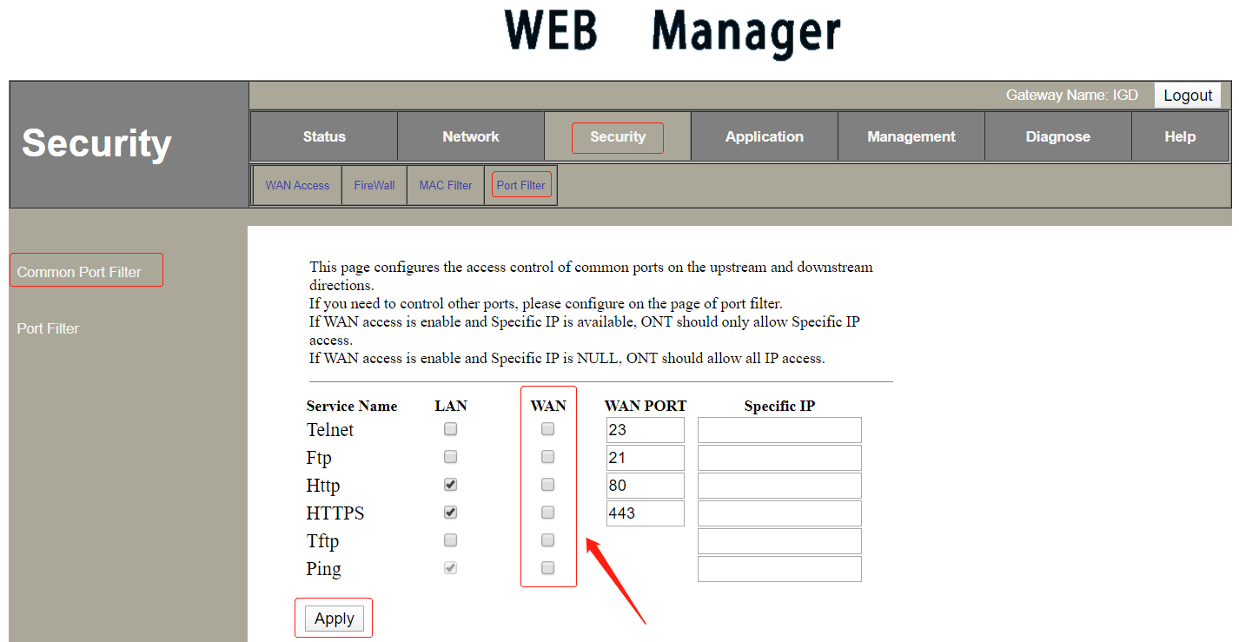

1. Enable attack protection

